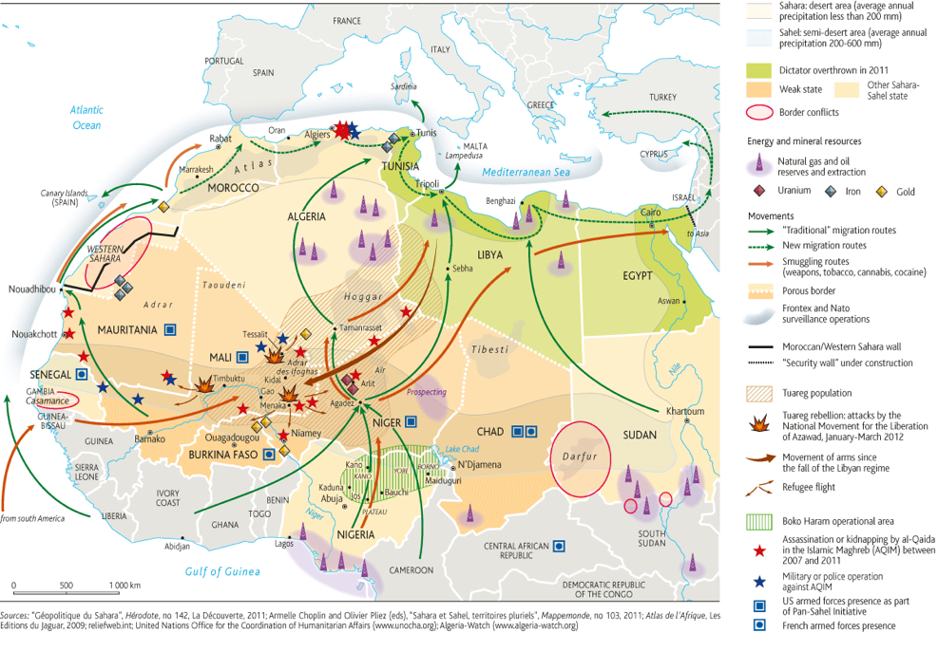

Mineral Extraction in the Sahara (Arid Environment)

- Refer to the map above to find Niger. Describe the location of Niger in the Sahara.

- Find the area of the Sahel inhabited by the Tuareg population. Describe the boundaries of this area.

- Do some quick research online. Who are the Tuareg people? What is their (brief) history?

- Which minerals are found in Niger?

- According to this map what other types of activities are taking place in countries bordering Niger?

First Video: Nigeria’s Natural Wealth Exploited

- What happened in 2007 to exacerbate an already complicated issue?
- Describe at least three impacts of Areva’s Uranium mining on Niger’s Tuareg population.
- What is uranium and what is it used for? (You may need additional research)
- Tuareg people are nomads and herders. What are nomads?

Homework: 6b) Read “Niger’s Uranium – Blessing or Curse?”
Create a list (point form) of benefits and cons of Niger’s uranium mining…

Pros of Uranium Mining | Cons of Uranium Mining

