Pg. 153-155
1. Find a diagram and describe in your own words a constructive wave (swell wave). What type of beach is produced?
2. Find a diagram and describe in your own words a destructive wave (storm wave) What type of beach is produced?

3. Define swash and backwash
4. Define wave refraction and label a diagram to show this process
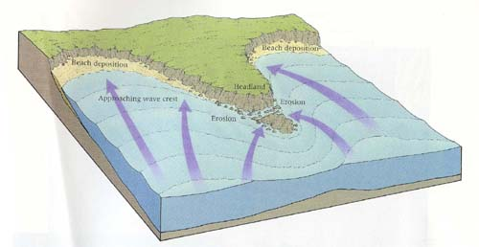

5. Define longshore drift
6. What causes the tides?
7. How does the tide affect coastal processes?

