Title:

1. Map to show…….
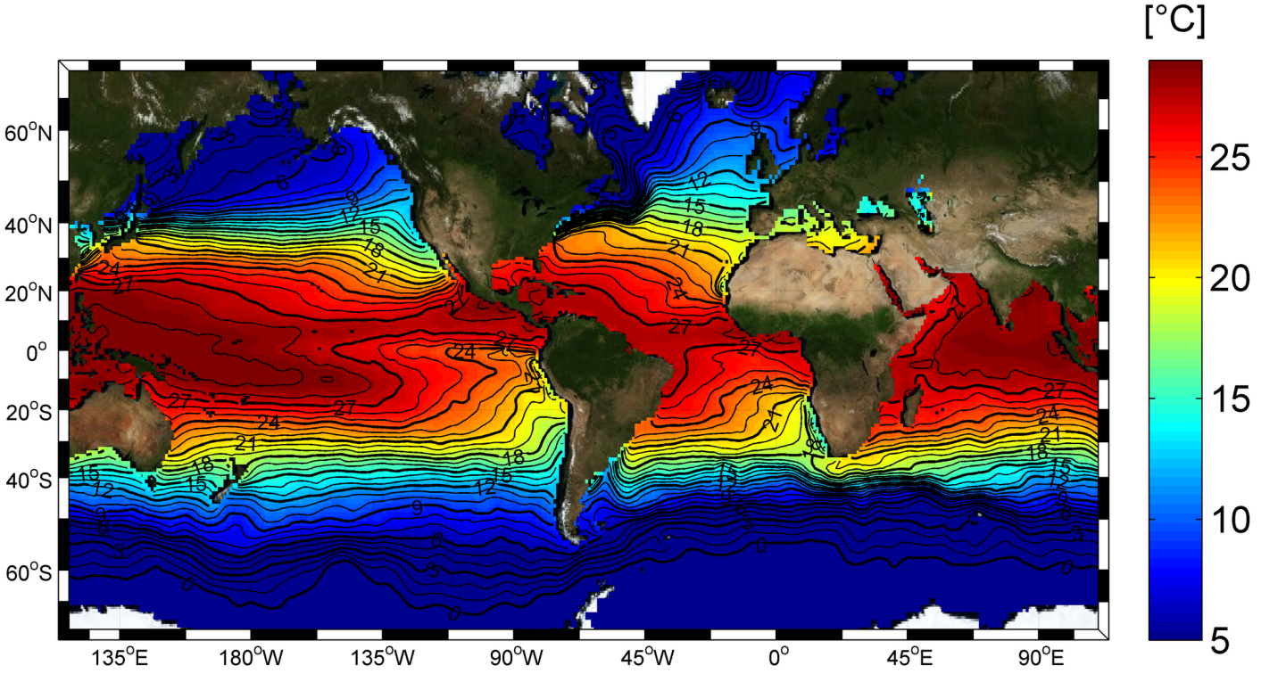
Describe the pattern of horizontal sea surface temperatures shown by the map.

2. Diagram to show ………..
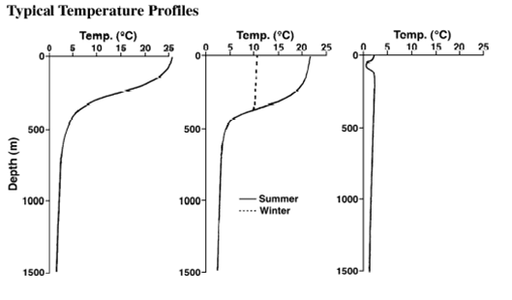
One of these diagrams is for the Bahamas, one of these is for Iceland and one of these is for France? Which is which? Explain your answer.

3. Map to show….
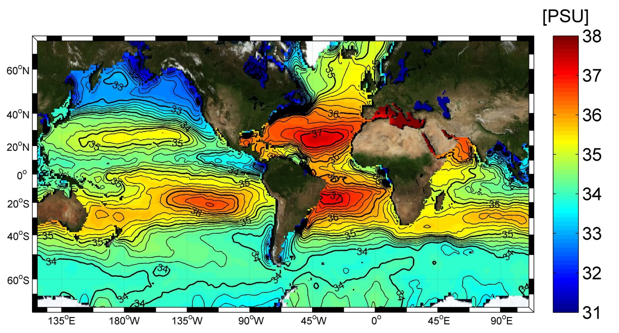
Describe the pattern of sea surface salinity shown by the map.
4. This is important because……..

Questions:
Textbook pg. 136-138
- Explain two reasons (factors) for the variation of sea surface salinity?
- How do ice bergs affect salinity?
- What is the difference in salinity at depth between tropical and polar seas?
- Which minerals form salt in sea water?
- Why are temperature and salinity important for density?
- What is specific heat capacity and does it affect climate?

