- Using the ranking for top services for overseas locations, answer the following:
- Name the top 5 countries.
- Why do you think their financial attractiveness is so high?
- What do you think it means by people skills and availability?
- Describe the results for the USA and the UK – why are they so far down the league?

- What are the 2016 patterns in International Outsourcing?

- Using the Kearney Index for 2009, describe the trends in ICT.
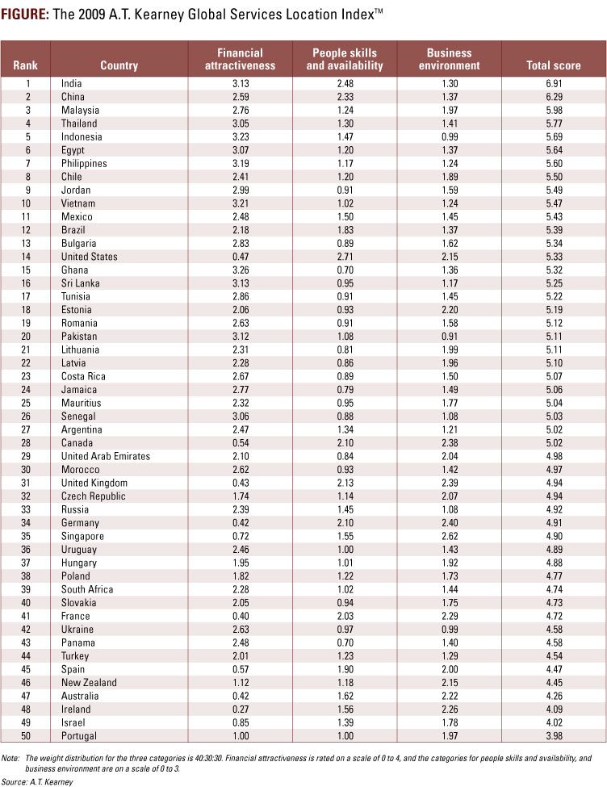

- How does ICT facilitate outsourcing?

- What other factors are involved?

- India V’s China
Use the book pg. 351 and your informed opinion to explain why India maintains an advantage over China in exporting services.

- Using one of the articles from the website (6c), provide a brief summary of the development of Business Process Outsourcing in the region and the importance of ICT in its development.

IB practice question: Explain the role of ICT in the growth of international outsourcing. (10)

