Task 1
Add information to the table below that gives specific information about location and use in Grand Bahama - In Blue!!

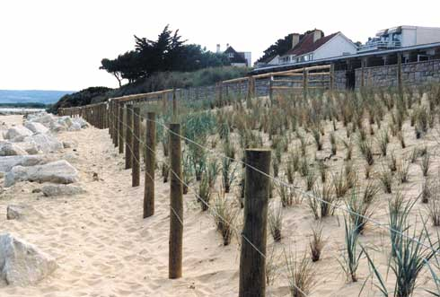 | Dune Stabalisation: Dune stabalisation is planting vegetation on the berm of the beach or on the dunes. By planting vegetation you should be making them more stable (roots) and reducing the moisture content (root uptake). | 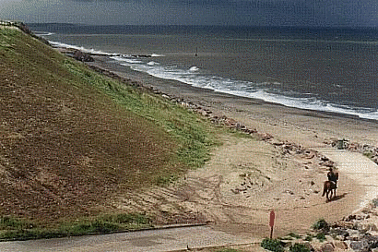 | Cliff Regrading: This means make cliffs less steep. Cliffs often become unstable because of undercutting. By reducing the angle you should reduce the undercutting and the risk of the cliff collapsing.
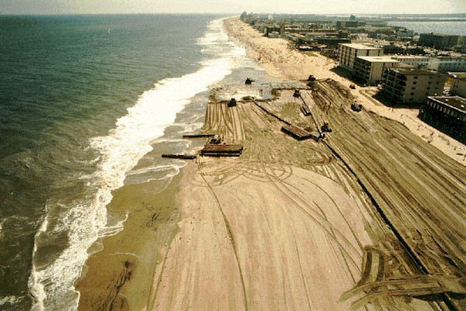 | Beach Nourishment: This is simply adding more sand to the beach. Beaches are natural defences, so by making them bigger, you are creating a natural defence. Sand is sometimes taken from the sea bed or dunes inland. | 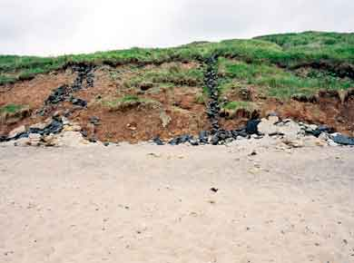 | Beach or Cliff Drainage: Cliffs often collapse because they become saturated and the increased stress causes them to collapse. By removing some of the excess water you should reduce stress on the cliff.
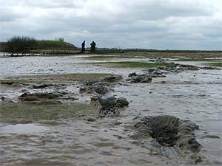 | Managed Retreat: This is not always a popular solution, because it is basically allowing the sea to take back land. Low value land is often chosen to be flooded by the sea. By allowing this you are changing some inland ecosystems by adding salt water. This not the same as doing nothing! Some areas are sacrificed to save others | 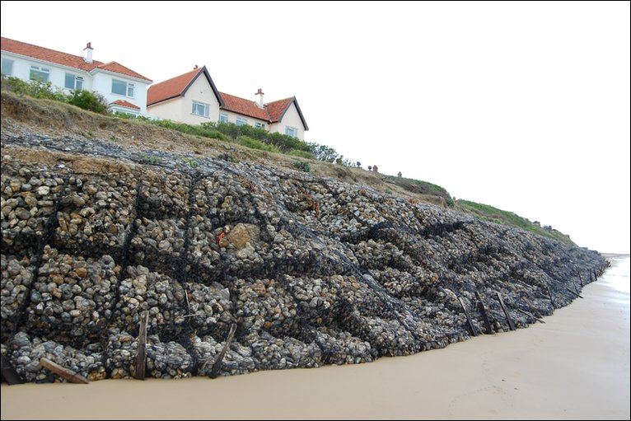 | Gabion: Gabion also uses large boulders, but this time the boulders are placed in cages. The gabion absorbs the power of the waves.  The gabion can be installed quickly and again is fairly effective. However, it also looks ugly, reduces access and can be expensive.
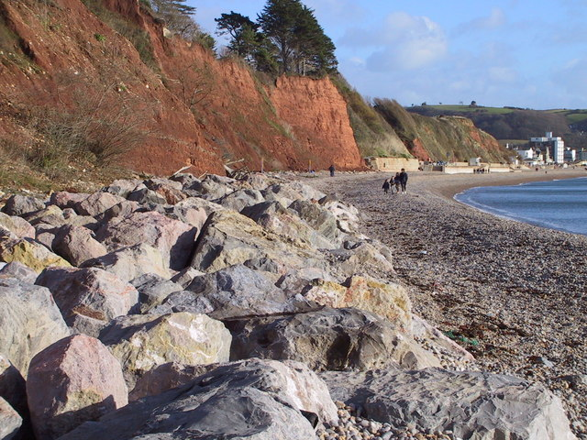 | Rip-rap or rock armour: Giant boulders placed at the foot of cliffs. Rip-rap is designed to absorb the waves energy and protect the cliffs behind. Rip-rap can be effective, but does look ugly, may reduce access to the beach and can be expensive. | 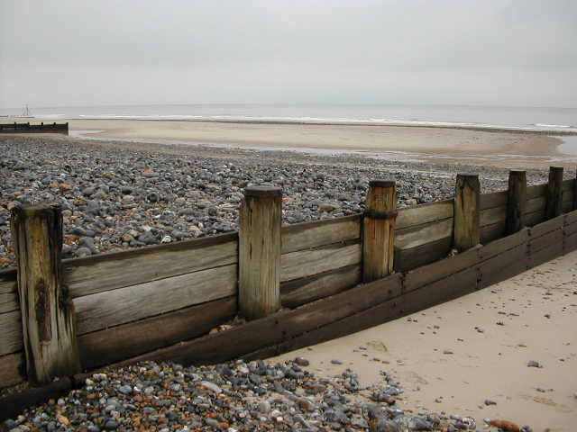 | Groynes: Groynes stop longshore drift transporting away beach material. The beach builds up and protects the cliff by reducing power of waves.  They can be effective in maintaining a beach, but need replacing regularly, look ugly and can cause problems down the coast. There is always rapid erosion after the last groyne.
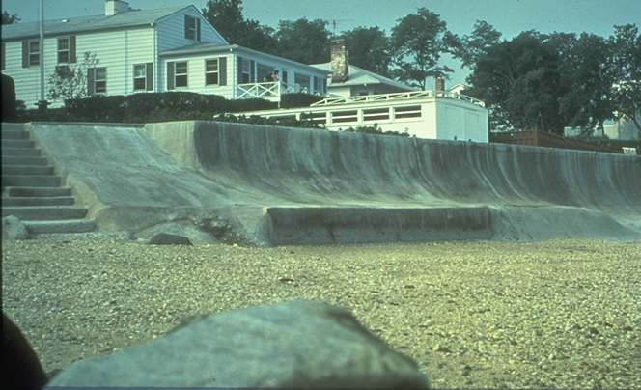 | Sea wall: Sea walls are made out of concrete and are aimed to absorb wave energy. Sometimes they are curved to direct the waves energy back out to sea. They can be very effective, but again are expensive, ugly and reduce access. | 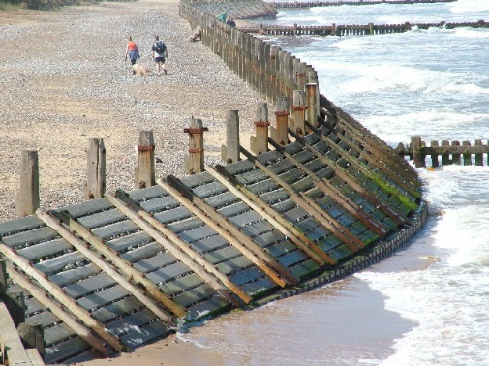 | Revetments: They are similar to sea walls, but often built out of wood. Often found at the foot of cliffs they are designed at absorb the waves energy. Again they need replacing regularly and do not protect against big storms.
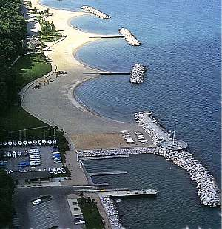 | Offshore break – A structure is created offshore and this reduces the power of waves so a beach can build up. Cheap to build but can change local ecosystems. Sometimes an offshore break is built out waste materials and can create a coral reef. | 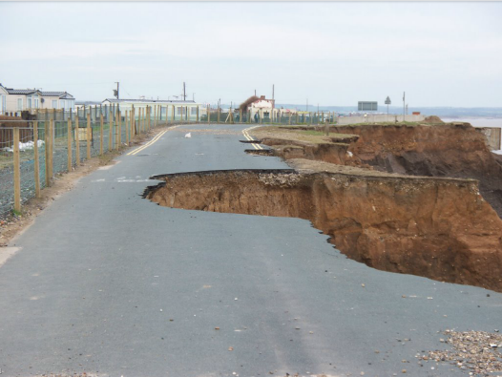 | Do nothing – Accept that nature will win. Cost effective but often unpopular locally.

Hard engineering:
Soft engineering:

Task 1
IB Question

Task 2 – The perfect essay
- Highlight information specific to grand Bahama
- Highlight areas of positive evaluation
- Highlight areas of negative evaluation
- Add three more details
- Write a conclusion at the bottom!

Evaluate the methods of coastal management for a named area. (10)
Sea level rise and risk of storm surges in hurricanes means that coastal erosion and protection from coastal flooding are priorities in Grand Bahama. Many tourist resorts and residential properties are built along the coast. Most of the main roads run along the coast. Tourism makes up 60-70% of the Bahamian economy.
Sea walls protect major coastal settlements and roads such as High Rock and Williams Town.
The Sea wall at Williams Town is not curved so whilst it is a barrier, it will need to be more frequently maintained as it does not deflect the wave energy but rather absorbs it all. Sea walls have been shown to be ineffective as it makes the beach profile steeper over time and therefore increases wave height and worsening erosion of sand. This means that during a storm, the wall is in danger of collapse as it will have lost its protective sand.
Rock groynes build up and protect the beaches for the larger resorts such as Our Lucaya resort – these are important to the economy and tourists will not come if the beach is not wide. Groynes trap sand and the sand attracts tourists as well as protecting the coast. Our Lucaya hotel beach was replenished after the last period of hurricanes. Beach replenishment has created a different sand texture that is different to typical Bahamian sand – much coarser. Gabions used in some tourist areas like Paradise Cove but they are visually unattractive and only used where tourists can’t directly see them.
Groynes are visually unattractive for tourists and prevent full access to the beach. Erosion after the last groyne can be seen in Port Lucaya where there is a large beach in front of the hotel but the beach shrinks where the residential area begins and the sea is undercutting the residents wall at high tide.
The groynes are more natural than a sea wall. Sea walls are used where there are fewer tourists such as Williams Town, as sea walls prevent beach access.
Breakwaters protect the port area and entrances to the canals and – very important to the island economy – largest deepwater port in Western hemisphere.
The Bahamian government is moving towards using vegetation and revetments to stabilise beaches rather than sea walls as this has fewer impacts a further down the coastline. Casuarina trees were planted but they were not native and their roots actually increased erosion. Sea Oats were planted on dunes in Abaco but dunes don’t offer protection from storms and homes may be at risk.
Conclusion……………………………………..

