Deepwater Horizon Oil Spill – April 20, 2010 Gulf of Mexico
Global Interactions HL Extension
- Discuss the environmental consequences of increasing international demand for one raw material.
- To discuss a transboundary pollution event
SL Core Patterns in Resource Consumption
- Environmental Impact of Increased Oil Demand
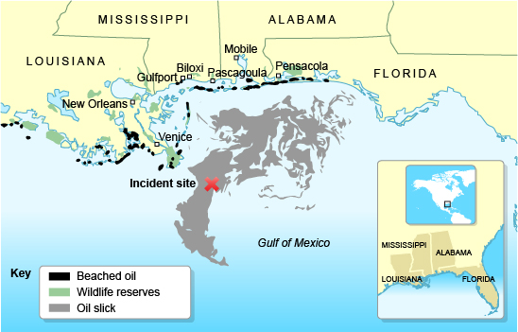

Notes:

Tasks: Using the prompts below, move the statements to answer questions; delete the table when finished.
- Briefly describe the BP Oil Spill
- Outline the key SHORT term and LONG term.
- In what ways are the impacts of the oil spill INTERNATIONAL?
- In what ways was the oil spill managed?

The Deepwater Horizon was a 9-year-oldsemi-submersible, mobile, floating,dynamically positioned drilling rig that could operate in waters up to 10,000 feet | Oil leaked at a high rate which is difficult to calculate. Some estimates are around 40,000 barrels a day. | On 20 April 2010, high-pressure methane gas from the well expanded into the drilling riser and rose into the drilling rig, where it ignited and exploded, engulfing the platform
The immediate effect was that it killed 11 people and injured 17 others. | Local industries, such as fishing was threatened. There was a ban on fishing in the water. | More than 2/3 of bottlenosed dolphins in the Gulf area have failed to birth viable calves (young) in the six years following the BP disaster.
Plants and animals were completely covered in the oil. Seabirds, sea turtles and more than 150 dolphins were found dead. | Fish stocks were harmed, and productivity decreased. Since the 2010 spill, Louisiana's statewide oyster catch has dropped by more than 25% | The size of the oil spill was one of the largest America had seen. However because the oil entered warm waters, organisms in the water helped to breakdown the oil.
Much oil was released at depth and there is scientific uncertainty about its impact on the ocean floor over the long term. 30% of the oil from the spill is still unaccounted for 6 years later. | Oil was naturally dispersed, collected in large booms and chemically dispersed and burnt.. The dispersants used are themselves hazardous chemicals. Tar balls reaching beaches were cleaned. | BP says it has paid out $32 billion for the disaster, including $14 billion for cleanup. It's also spent $300 million on everything from testing seafood to its ad campaign that encourages people to come back to the Gulf
The U.S. Travel Association estimated that the economic impact of the oil spill on tourism across the Gulf Coast over a three-year period could exceed approximately $23 billion, in a region that supports over 400,000 travel industry jobs generating $34 billion in revenue annually | The pollution along coastlines in the Gulf is up 20% 6 six years, and the oil contaminated approximately 1300miles of coastline in Gulf states Louisiana, Mississippi and Florida. | "The problem is right when they used the dispersants, that's when the tuna came to the Gulf to spawn," said Cheril Carey, a national sales representative for a company specializing in yellow fin tuna. "It takes a tuna five to 15 years to mature. So although we may have fish now, we may not have them in five to 15 years.
Potentially, oil entering the Loop current in the Gulf of Mexico could go through the Florida Strait, with potential oiling of shorelines and marine resources along the western edge of Cay Sal Bank. Over time, there is the potential for oiling along the Biminis, Great Isaacs, West End Grand Bahamas. | After Hurricane Isaac in September 2012, about 565,000 pounds of oiled material traced to the spill was brought to land. This was a greater amount than had been collected in the eight months prior. | ExxonMobil, Chevron, ConocoPhillips and Shell have made plans to fund a billion dollar joint venture to build a new rapid response capability for deep water offshore drilling response in the Gulf of Mexico
BP is one of the largest UK own Trans National Corporations. On 25 June, BP's market value reached a 1-year low. The company's total value lost since 20 April was $105 billion. | 20% of the juvenile bluefin tuna were killed by the oil spill. Exacerbating the 82% decline of the tuna's spawning stock in the western Atlantic during the 30 years before the oil spill | The Gulf is used for foraging by seabird species that breed in the Caribbean and Mexico which may be harmed by direct contact with oil or by eating or being fed oiled prey or tar balls.
The real estate prices and a number of transactions in the Gulf of Mexico area decreased significantly during the period of the oil spill | On 30 April 2010 President Obama ordered the federal government to hold the issuing of new offshore drilling leases and authorized investigation of 29 oil rigs in the Gulf | The U.S. State Department used assistance from 8 countries who provided skimming boats and equipment

