Global Energy Budget
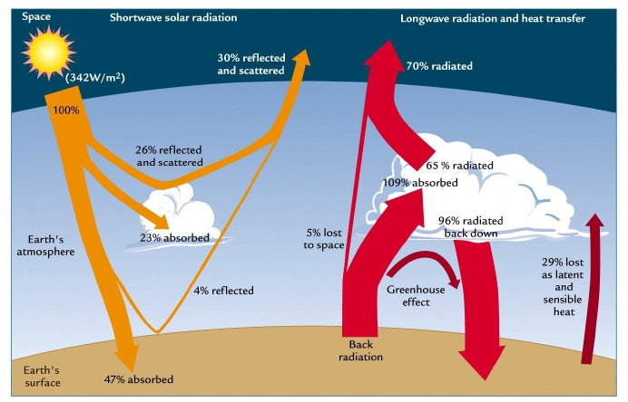

Explain the atmospheric energy budget (use the website and also page pg. 53 of the IB book 'Course Companion')
____________________________________________________________________________________________________________________________________________________________________________________________________________________________________________________________________________________________________________________________________________________________________________________________________________________________________________________________________________________________________________________________________________________________________________________________________________________________________________________________________________________________________________________________________________________________________________________________________________

