What factors are important in choosing a venue for a major sporting event?

Case study of a contemporary international sports event

London Olympics
In 2012 London will host the 30th Modern Olympiad and become the first city to host the Olympics three times (1908, 1948 and 2012). London was selected to host the games over eight other cities. In 2003, the nine competing cities were; Paris, New York, London, Moscow, Leipzig, Istanbul, Rio de Janeiro, Madrid and Havana. After initial inspection reports the IOC reduced this number to five cities; Paris, New York, London, Moscow and Madrid. These five cities went head-to-head in a vote on 6th July 2005. Despite Paris being a strong favourite, London beat Paris in the final round of voting by 54 votes to 50 votes. I am going to look at why London won the right to host the Olympic games, where it will be hosted (venues), who will attend (athletes and supporters) and what the impacts (positive and negative, short-term and long-term) are likely to be.
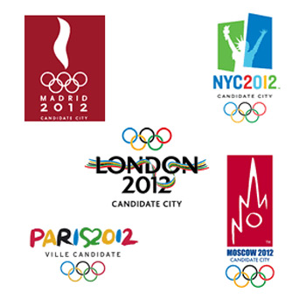
Firstly though, who are the IOC? The IOC is the International Olympics Committee and it based in Lausanne, Switzerland. It was founded in 1894 and currently has 205 member countries. The IOC selects the hosts for the summer and winter Olympics and helps with organisation. The current president is Jaques Rogge from Belgium. The IOC can have up to 115 members at any one time. These members aim to promote the IOC's mission (see below) and select host cities. These members are now voted in by member countries and each serves a term of eight years before they must stand for re-election.
In recent years the IOC has been very keen to make all Olympic games, economically, socially and environmentally sustainable.
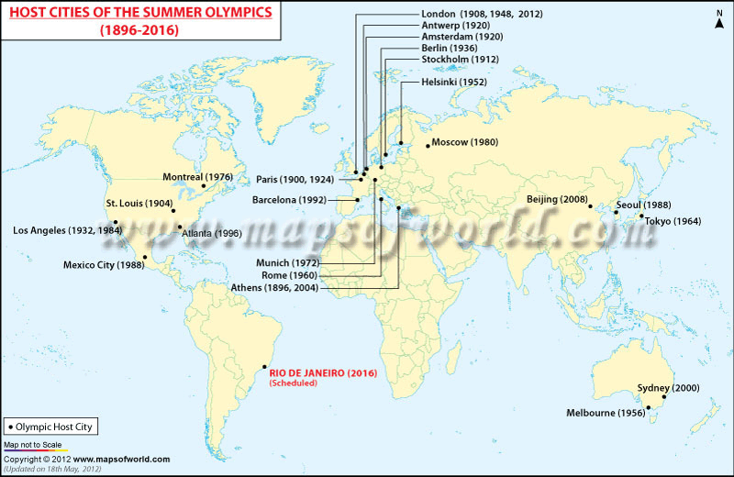

Location
Although London was chosen as the host city for the 2012 Olympics, it is not possible for all events to take place in Central London. Events like sailing need the sea, rowing a 2km straight course (the River Thames is too busy), shooting an area away from houses and football needs big stadiums. Therefore, some events are being held outside London, including Glasgow and Cardiff. Within London most events are concentrated in East London in the borough (district) of Newham. Newham is going to be home to the Olympic Village. Newham was selected because it gave the borough a chance to be regenerated and had a large area of available land. Newham was a very important location for industry 100 years ago. However, as ships became bigger and the River Thames less useful and as manufacturing moves overseas Newham went into decline. Factories became derelict and unemployment went up. Now though with the arrival of the Olympics areas of brownfield land have been cleaned and built on and residents are finding jobs in construction and Olympic preparation.

Locational Factors
Below are a list of factors that made London a good location to host the 2012 Summer Olympics.
ECONOMIC | SOCIAL AND CULTURAL | POLITICAL | PHYSICAL (ENVIRONMENTAL)
- London has five international airports (Luton, Stanstead, City, Heathrow and Gatwick). London City is located very close to the Olympic Village.  - London has a good rail network. Newham is connected by the underground, overground, mainline rail, Docklands light railway and Eurostar.  - Many of the venues were already in existence e.g. Wembley, Lord's, Wimbledon and the O2 arena.  - The government guaranteed to cover the cost of the Olympics.  - The UK has a successful track record of hosting major sporting events, it hosted the European football championships in 1996 and the Commonwealth Games in 2002.  - London is world city, so it is easy to attract sponsorship and advertising to the venue. | - London and the UK has a tradition of sport. Lord's is the home of Cricket, Wimbledon the home of tennis and Twickenham the home of rugby. It also has many other famous sporting venues in the capital like the O2 arena, the Emirates and Wembley.  - London championed the idea of leaving a legacy. They said that a poor area would be regenerated and venues would be left for future use.  - They had the backing of celebrities, Lord Sebastion Coe (former Olympic champion) and David Beckham helped with the bid process.  - The bid team used local residents to further their course and to show that it had the backing of the local population. Thirty of the final 100 bid team in Singapore for the vote were local Londoners.  - All venues will be used after the Olympics. They will either be made smaller or dismantled and moved to other parts of the country.  - There are a large number of hotel rooms in and around London. | - The bid had the support of the local and national government. Tony Blair was the only leader to attend the bid decision.  - The then mayor of London, Ken Livingstone, put aside his difference with the then Prime Minister Tony Blair to fully support the London bid.  - The current Prime Minister (David Cameron) and London Mayor (Borris Johnson) also strongly support the Olympics. | - The were large brownfield sites in Newham that could be used to construct the Olympic Village on.  - East London is built on a floodplain so the land is flat and easy to build on. The East of London should be protected from flooding by the Thames Flood Barrier.  - During July and August, London normally has a good climate for participating in and viewing sport (not too hot or cold, not much rainfall).  - London and England are in Europe, so close to many of the Olympics potential athletes and spectators.

Problems with the location?
As with most things the location of London is not perfect and there are some negative sides of it been selected.
- London is already a developed city, so selecting London may have taken the opportunity of other cities like Istanbul or Havana to develop.
- London is one of the world's most expensive cities to visit and live. Many potential spectators will be put off by the expense.
- Some businesses had to be closed and relocated to make way for the Olympic village.
- There have been questions marks, whether London's transport network can cope with the influx of visitors.
- There is the risk that the Olympics might attract a terrorist attack. In fact the day after London won the Olympics, it experienced a major terrorist attack.

Transport
London's transport did come in for some criticism during the bid process. However, since winning the right to host the games there have been significant improvements. About $17 billion has been spent on improving public transport over the five year period leading up to the games.
London Docklands's Light Railway: This a driverless system that covers a large area of East London. It will have direct links to the Olympic Village as well as London City airport, the North Greenwich Arena and ExCel arena.
Overground and Mainline: It is estimated that 80% of spectators will arrive by train. It is planned for a train to arrive in the Olympic Village area every 15 seconds. The main East London Line is currently going through a major upgrade and extension that will be ready for the Olympics. New trains have also been introduced to transport visitors from central London. The new trains will be known as Javelin trains and will take less than 10 minutes to travel from Central London.
Underground: Three underground lines; the District, Jubilee and Hammersmith and City travel out to East of London and will play a vital role in transporting spectators between venues.
Eurostar: There is a new Eurostar terminal that has been built in Stratford, right next to the Olympic Village. The Eurostar has direct connections to Paris and Brussels and makes connections to the European rail network.
Airports: London has five international airports; Stanstead, Luton, Gatwick, Heathrow and London City. London City is the closest airport to the Olympic Village and is actually connected by the Docklands Light Railway. London Heathrow is the world's busiest international airport so spectators and athletes will be able to travel to London from virtually any country in the world.
Roads: The aim is that no one will arrive at the Olympic Village by car. There will be park and ride schemes set up around London, where people can then transfer to trains and buses. It is estimated that about 15% of spectators will arrive using park and ride. The London congestion charge should also discourage people from wanting to drive into London during the games.
Walking and Bikes: People will be encouraged to walk in and around venues. There are walkways around the Olympic Village and a cable car is being constructed across the Thames to connect the village with other venues. The current mayor of London has also recently introduced a bike scheme in London where spectators can borrow bikes. It is estimated about 5% of spectators will walk or bike to the venues.

What is the sphere of influence of the Olympics?

Athletes and Spectators and Tickets
Athletes: It is estimated that over 10,500 athletes will compete in the Olympics from all 205 member countries of the IOC. Because, the Olympics is a truly global event then the sphere of influence id the whole world.
Spectators: It is impossible to calculate exactly how many people will visit the Olympics. Nearly 10 million tickets will go on sale for the Olympics and Paralympics and estimates have been made up to 4 million different individuals visiting te games. Again spectators will travel from all over the world, but the majority will come from the UK, Europe and North America. Travelling to the UK as well as finding accommodation and buying a ticket will not be cheap so most spectators will come from MEDCs.
Sphere of influence: The area people travel from to access a service, visit or attend an event.
Ticketing
- There will be 9.6 million tickets for sale - 8 million for the Olympics and 1.6 million for the Paralympics.
- Organisers say 75% of all tickets will cost less than £50 and offer free travel on London transport.
- A sell-out rate of 82% for the Olympic Games and 63% for the Paralympics is estimated.
- Tickets for the athletics will start at £15 and there will be 20,000 £10 tickets for the Olympic Park to watch events on big screens.

The costs and benefits of hosting the Olympics
- short- and long‑term
- local (in London) and national (UK) scale

National scale - Costs
- On 15 March 2007 the government announced the budget for the Games had risen from £2.4bn to £9.35bn, although she said the cost of the Games would be £5.3bn.
- New venues will cost £3.1bn. These include the Olympic Park at Stratford and the athletes' village.
- There will be £1.7bn spent on regeneration and infrastructure.
- £600m will be spent on extra security.
- The government has set aside £2.7bn in a contingency fund in case costs rise further.
- The Olympics will have to pay an £840m tax bill.
- £390m will be spent on other costs, such as the Paralympics and community sport.
- Income: The government will provide £6bn, with other funds coming from London council tax payers and the National Lottery. Further income will come from International Olympic Committee TV and marketing deals (£560m); sponsorship and official suppliers (£450m); ticket revenues (£300m); licensing (£60m); London Development Agency (£250m)

National Scale – benefits
Multiplier effect of increased number of visitors to all parts of the UK

Venues and Sports
There will be 26 different sports in the London Olympics which break down into 39 different disciplines. Because of the large number of sports, it is necessary to have a wide variety of venues.
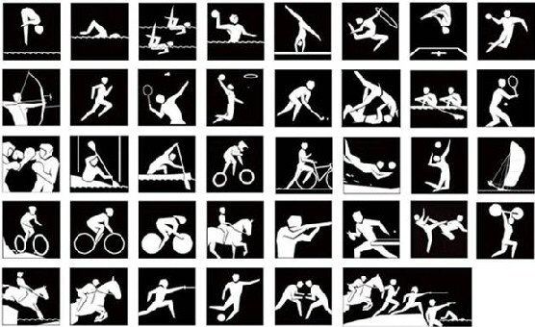
Thirty one different venues are being used during the Olympics. The majority of the venues are concentrated in the Olympic Village and London, but some events like football and sailing are being staged around the UK.
The Olympic Village | Inside London | Outside London
- Aquatics Centre (swimming and diving)  - Olympic Stadium (athletics and opening and closing ceremony)  - Basketball arena  - Velodrome (track cycling)  - BMX circuit  - Water Polo arena  - Hockey Centre  - Eton Manor (Paralympic tennis)  - Handball arena | - Hampton Court Palace (road cycling)  - Lord's cricket ground (archery)  - Wembley (football)  - Wembley Arena (badminton)  - Wimbledon (tennis)  - Horse Guards Parade (beach volleyball)  - North Greenwich Arena (Gymnastics)  - Earls Court (volleyball)  - Hyde Park (triathlon)  - The Mall (marathon)  - ExCel (table tennis, fencing, judo)  - Greenwich Park (show jumping)  - Royal Artillery Barracks (shooting) | - Millennium Stadium (football)  - Villa Park (football)  - St. James Park (football)  - Hampden Park (football)  - Weymouth and Portland(sailing)  - Old Trafford (football)  - Eton Dorney (rowing)  - Lee Valley White Water Centre (kayaking)  - City of Coventry Stadium (football)  - Hadleigh Farm (mountain biking)
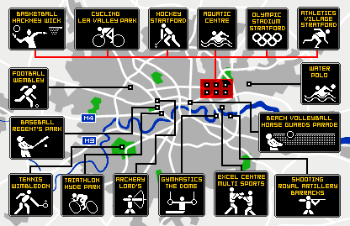
SHORT-TERM POSITIVE | SOCIAL AND CULTURAL  - Local residents will have the opportunity to go and watch world class sport on their doorstep.  - A new school/college has been built on the site of the Olympic Village. It will be the media centre during the games  - Jobs will be created selling merchandise, tickets, food, etc at Olympic venues. | ECONOMIC  - Hotels and restaurants should see a massive increase in business on the lead up to and during the Olympics and Paralympics  - Olympic merchandise will be sold across the world increasing revenue from the games  - Sponsorship and advertising should cover a lot of the costs from the games. | POLITICAL  - The British government will be in the spotlight at the time and the Prime Minister at the time will get publicity from opening the Games.  - There will be an increase in tax revenue during the games. | ENVIRONMENTAL  - Cars will not be allowed into the Olympic Village so all spectators will be walking, cycling or using public transport. This should reduce air pollution in the area of the Olympic Village.
SHORT-TERM NEGATIVE | - During the Olympics there will be road closures and increased traffic which will make it harder for Londoners to move around.  - London may become a terrorist target and at the very least there will be increased disruption because of security checks. | - The cost of hotels, restaurants, taxis,etc. will probably increase during the Olympic Games.  - Some businesses may have to close during the Olympics because of safety or accessibility problems (impossible to make deliveries) | - The Government will have less money to spend on roads, schools, hospitals, etc. while it pays for the Olympic Games | - There will be an increase in flights arriving into the UK which will cause an increase in air pollution. Also more energy will be used in hotel and venues.  - The increased number of spectators and athletes will increase waste and litter which will have to be dealt with.
LONG-TERM POSITIVE | - The venues will be available for the public to use decades into the future. Things like the velodrome, aquatics centre and white water centre should develop athletes in new disciplines.  - The Olympic village's accommodation will be converted and used as affordable accommodation.  - Equipment used in the Olympics will be given to charities for free.  - Local residents may see the value of their houses increase with all the regeneration taking place. | - The infrastructure improvements (especially public transport) will benefit Londoners and business for decades to come.  - The image of London should be enhanced making business and individuals want to do business in London. | - If the games are successful then the government will be seen in a positive light and might have a better chance of re-election.  - The UK should definitely improve its standing on the international circuit. | - The improved public transport should mean that people are removed from the roads and use public transport instead.  - Areas of brownfield land around London have been cleared of pollutants left over from factories.  - Previously covered rivers have been opened and cleaned. Areas of parkland have also been created.
LONG-TERM NEGATIVE | - It is estimated that Londoners will have an increased tax bill for the next ten years to pay for the Olympics.  - Many of the jobs created will only be short-term, so unemployment may rise after the games. | - There may be an oversupply of hotel rooms after the games. London is in the processing of adding 15,000 hotel rooms for the Olympics.  - The increased demand for facilities generated by the games may create inflation. | - The government may be saddled with long term debt paying off the games. | - More structures, hotels and accommodations will increase the country's carbon footprint.  - The creation of impermeable surfaces may affect the hydrological cycle.

How will the Olympic Games Regenerate East London?
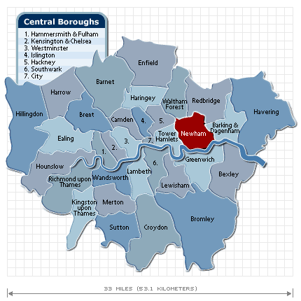
- It will create 9,000 new homes in the Olympic park (during the games the houses will be used for athletes). At least half of the houses will be low-cost affordable housing for key workers such as firemen, teachers or nurses.
- New schools and community centres will be built to accommodate the extra residents in Newham.
- Large brownfield sites will be cleared up in the Lower Lea Valley and the largest new urban park since Victorian times will be created in Newham.
- In total 1,850km3 of polluted soil will be cleaned (left over from its industrial past)
- Transportation will be improved (DLR (Docklands Light Railway), East London Line (train line) and Eurostar (international train link to Brussels and Paris).
- New sports facilities will remain (velodrome, swimming centre, stadium, BMX track, hockey pitches, etc.) that can be enjoyed by athletes and local residents.
- The facilities can be used for future events, the UK is bidding for many World Championships including athletics, cycling and swimming, all of which can use existing stadiums and create future investment and jobs. West Ham United football team bidding for the right to use the Olympic stadium after the Olympics - this secures long term jobs.
- 12,000 new permanent jobs will be created (managing new facilities, working in hotels and new transport links, etc.). Thousands more temporary jobs will be created during the games.
- A new media centre will be built that will remain after the games for creative arts
- The new open spaces and facilities will encourage a healthier lifestyle, hopefully increasing life expectancy and reducing problems like diabetes and obesity. The Olympic games itself should also inspire people to play more sport,
- Tourism will be boosted in East London (Sydney estimated that about $8 billion of extra tourist income was generated by their 2000 Olympic Games)
- The image of East London should be enhanced from its current one of deprivation and unemployment into one of regeneration.
- The River Lea is being cleaned and opened up, It previously ran underground and was heavily polluted.
- New bridges will be built across the River Lea to improve transport links and accessibility. The cleaner river Lea should also attract fish and animal life to return.
- Overhead powerlines (13km) have been moved underground make the environment more pleasant and possibly safer (some people believe that powerlines can cause health problems)
- The positive multiplier effect will attract new businesses e.g. restaurants, sports shops, etc. to Newham. Also money earned by the 12,000 extra people of jobs will be circulated in the local economy.

Objections to the Olympic Games

- Over 300 new businesses have been relocated to make way for the Olympic Park.
- 450 houses had to be demolished
- The UK's largest church was demolished
- The construction process will create noise, visual and air pollution
- Some trees were removed to make way for building (500 trees)
- 87 allotments (private gardens) were lost
- The Olympic Games could be a potential terrorist threat endangering local residents
- London council taxpayers will have to pay for about $1 billion of costs to build the Olympic Park
- Construction work has increased road traffic
- There will be road restrictions during the game
- The games may have caused localised inflation meaning some first time buyers are priced out of the market
- Some travellers lived on the brownfield sites of the Lower Lea Valley and were forced to move on
- Many jobs will only be temporary

