Letter writing:
Using your textbook pages 150-151 and the presentation (on the website)
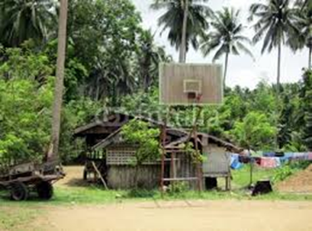
Imagine you are the daughter or son of rural farmers in a LIC country at your age now.
(think: Africa, Asia, Middle East or South America).

Write to your cousin who lives in a city and tell them your reasons for wanting to leave the countryside and leave in the city.

Tell them what your life may be like at home and why you think life would be better in the city. What are your future plans?

Include the name of the city you plan to move to and 2 pieces of information specific to that city.

At minimum 10 sentences.

CATEGORY | 4 | 3 | 2 | 1
Content Accuracy | The letter contains at least 5 accurate facts about the topic, including all relevant information from class or textbook. | The letter contains 3-4 accurate facts about the topic, including most relevant information from class or textbook. | The letter contains 1-2 accurate facts about the topic including some relevant information from class or textbook. | The letter contains no accurate facts about the topic, including little relevant information from class or textbook.
Ideas | Ideas were expressed in a clear and organized fashion. It was easy to figure out what the letter was about. | Ideas were expressed in a pretty clear manner, but the organization could have been better. | Ideas were somewhat organized, but were not very clear. It took more than one reading to figure out what the letter was about. | The letter seemed to be a collection of unrelated sentences. It was very difficult to figure out what the letter was about.
Length & Sentences | The letter is more than 10 sentences. Punctuation is correct and sentences structure appropriate to the assignment. | The letter is 10 sentences. Punctuation is correct and sentencs structure appropriate to the assignment. | The letter is 8-9 sentences. Punctuation is mostly correct and sentences structure appropriate to the assignment. | The letter is 5-7 sentences.Punctuation is mostly correct and sentences structure appropriate to the assignment

/ 16

