Landslides – Geophysical Processes

Mass movements include:
• Landslides
• Rock falls
• Avalanches
• Mud flows
• Debris flows
• Creep

Characteristics of ALL mass movements:
- Material moves downslope due to the pull of gravity
- Can happen almost anywhere
- Commonly associated with other events (heavy rainfall or earthquakes, for example) and are therefore under-reported (as considered a ‘secondary’ hazard to primary event)
- Movements can either be catastrophic (slope failure) or slow and steady (creep)
- The rate of the mass movement can be increased by various erosive agents (especially water)

Mass Movement Classification:
The importance of external and internal factors such as water for the movement, speed of onset, duration of event and frequency of landslides determines their classification. See diagram below.

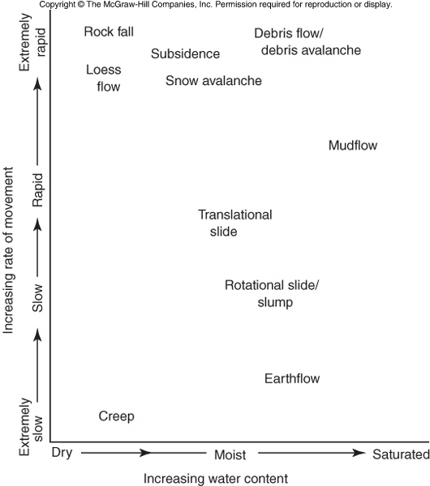

Internal and External Factors:
Gravity - hill slopes more vulnerable (on top of a hill, on the slope, or at the bottom of a hill), modified slopes (road cut, cut flat area to build on, coastal erosion, etc.)
Water - risk is higher when ground is saturated and/or during heavy rains, El Niño events
Earth Materials - loose soils (particularly clay-rich) or fractured rock, and old landslides pose greater risk
Triggering Events - heavy rain during storm, rain after big storms or fires, earthquakes (when ground is saturated?), human structures & building or modifications

The Weight of Water:
- Sedimentary rocks commonly have porosities of 10 - 30%
- If pore spaces fill with water, the weight of the material is increased substantially, creating instability
- Solifuction is a downward movement of wet soil along the slopes under the influence of gravity.

Type of Landslide #1: Debris or Mudflows
- Types of mass movements that behave like fluids (solifuction)
- Unlike slides, flows are not controlled by a failure surface, but instead are dominated by internal movements (such as water (weight & interaction with clay minerals), decreasing rock cohesion, incompetent/weak material, adverse geologic structures)

Type of Landslide #2: Soil Creep
- Downslope movement of soil and uppermost bedrock
- Creep happens at too slow of a rate to observe directly
- Instead, creep can be identified by it’s effect on objects
- Creep is involved up to shallow depth (app. 1-2 m), whereas the rapid flow is involved to greater depth (app. up to 5 m or more)

Type of Landslide #3: Rockfall
- Debris slides - are failure of unconsolidated material on a surface; rock slides or rock falls are where movement of large rock block rolls
- They are also common along the steep banks of rivers, lakes etc.
- Pore water pressure is the key to monitoring landslides. Shear strength (a resisting force) decreases and the shear stress (driving force for slides) increases.
- Talus – accumulation formed by the coarser rock fragments resulted from the mechanical weathering along a slope under influence of gravity (at bottom of rockfall)

Questions for Review (read pgs 174-176 and use notes above):
1) Estimate the relative speed of mudflows vs. creep.
2) Classify the following mass movements: soil creep, avalanche, rockfall
3) Suggest which factor (internal or external) is most responsible for rockfalls.
4) Explain the effect of gravity on landslides.
5) Explain the difference between shear strength and shear stress.

