Geography coursework
Textbook pg. 405-437

Overall aim of investigation:
To what extent are the beaches of Freeport/West End polluted by ocean plastic?

Introduction - Fieldwork question and geographic context - 300 words

- Describe Grand Bahama and the beaches we have studied. Imagine you are talking to someone who has never been here.
- Introduce some of the impacts people have on the beaches of Grand Bahama
- Say which part of the syllabus this coursework relates to.

- Locate Grand Bahama and each beach using a labeled map – You should draw this map by hand. If you use a map from the internet you must add your own features to it. (keep a record of all web addresses you use) Include a title, key, scale, North line.

- State each hypothesis and justify it using geographical theory

Methods – 300 words
- Describe the date, time and weather conditions of your field work collection. Remember to take photographs or draw diagrams to help show what you did.

- State each hypothesis and describe the method of data collection so that someone else could follow your instructions.
- Explain why this is a good method and will get you accurate results.
- You should include a discussion of sample size and type of sampling technique chosen, sample site selection

Data presentation and Analysis - 1,350 words

- State each hypothesis
- Draw a graph or diagram or map to display the results. Include a title, key, axis, scale etc
- Describe the basic pattern shown by your graph
- If possible, use statistics to analyse how significant your pattern is such as spearmans rank, error bars of standard deviation, chi squared test.
- Explain the geographical reasons for this pattern.
- Identify any anomalies and try to explain them
- Are there any links between your hypothesis – write about them

Conclusion - 200 words
- State each hypothesis and say whether or not you proved it was true. Give a brief summary why you found this.
- Overall comment on the extent of pollution on each beach.

Evaluation – 300 words
- Was the data you collected sufficient to be able to answer your hypothesis?
- Think of two things you would change about the fieldwork methods to make your data more accurate – think about your sample size or accuracy of your methods. How these changes would affect your overall results?
- If you were going to take this investigation further what would you do?

Double check this list
- Name, overall aim, candidate number and word count on the front page, the work is within the 2,500 word limit.
- Overall presentation is neat and well structured, pages are numbered with a contents page
- References used for background information follow standard conventions. (reference page)
- All illustrative material is numbered, is fully integrated into the body of the report and is not relegated to an appendix.

Internal assessment criteria—SL/HL
There are seven internal assessment criteria for fieldwork.
Criterion A | Fieldwork question and geographic context | 3 marks
Criterion B | Method(s) of investigation | 3 marks
Criterion C | Quality and treatment of information collected | 5 marks
Criterion D | Written analysis | 10 marks
Criterion E | Conclusion | 2 marks
Criterion F | Evaluation | 3 marks
Criterion G | Formal requirements | 4 marks
 | Total | 30 marks

A Fieldwork question and geographic context
This criterion assesses the focus and geographic context of the fieldwork and whether the fieldwork question is related to the material in the syllabus.
Marks | Level descriptor
0 | The work does not reach the standard described by the descriptors below.
1 | The fieldwork question is inappropriate, or the geographic context or locational map or relationship to the syllabus is missing.
2 | The fieldwork question is adequate with an acceptable attempt made to place it in its geographic context and relate it to the syllabus. A locational map is presented.
3 | The fieldwork question is well focused with a detailed, accurate explanation of the geographic context and is related to the syllabus. A good locational map is presented.

B Method(s) of investigation
This criterion assesses the description, justification and appropriateness of the method(s) used to investigate the fieldwork question.
Marks | Level descriptor
0 | The work does not reach the standard described by the descriptors below.
1 | There is only a brief description of the method(s) used for information collection, and the method(s) are generally inappropriate for the investigation of the fieldwork question.
2 | There is an adequate description but limited justification of the method(s) used for information collection. The method(s) used are generally appropriate for the investigation of the fieldwork question.
3 | There is a clear description and justification of the method(s) used for information collection. The method(s) used are well suited to the investigation of the fieldwork question.

C Quality and treatment of information collected
This criterion assesses the quality of information collected and its suitability for analysis in criterion D, and whether appropriate techniques have been used for both the treatment and display of information.
Marks | Level descriptor
0 | The work does not reach the standard described by the descriptors below.
1 | Limited or inappropriate information has been collected and very little attempt has been made to treat or display the information collected.
2 | Some relevant information has been collected and some attempt has been made to treat or display the information collected.
3 | The information collected is generally relevant to the fieldwork question and allows for some analysis. Limited techniques have been used for both the treatment and display of information collected.
4 | The information collected is generally relevant to the fieldwork question and is sufficient in quantity and quality to allow for analysis. Appropriate techniques have been used for both the treatment and display of information collected.
5 | The information collected is directly relevant to the fieldwork question and is sufficient in quantity and quality to allow for in-depth analysis. The most appropriate techniques have been used effectively for both the treatment and display of information collected.

D Written analysis
This criterion assesses the quality of the analysis of the results, referring to the fieldwork question, geographic context, information collected and illustrative material.
Marks | Level descriptor
0 | The work does not reach the standard described by the descriptors below.
1–2 | The report reveals very limited knowledge and understanding. The approach is descriptive with little or no attempt at analysis.
3–4 | The report reveals some knowledge and understanding. There is an attempt at analysis, which may be incomplete or superficial, making little or no reference to the fieldwork question, geographic context, information collected and illustrative material.
5–6 | The report reveals an adequate level of knowledge and understanding. There is an adequate level of analysis, which generally refers to the fieldwork question, geographic context, information collected and illustrative material.
7–8 | The report reveals a good level of knowledge and understanding. There is a well-reasoned, detailed analysis of the results with references to the fieldwork question, geographic context, information collected and illustrative material. There is an attempt to explain any anomalies in results.
9–10 | The report reveals a very good level of knowledge and understanding. There is a clear and well-reasoned, detailed analysis of the results with strong references to the fieldwork question, geographic context, information collected and illustrative material. The attempt to explain any anomalies in results is good.

E Conclusion
This criterion assesses the ability of the student to summarize the findings of the fieldwork investigation.
Marks | Level descriptor
0 | The work does not reach the standard described by the descriptors below.
1 | There is some attempt to draw a conclusion to the fieldwork question, which may not be completely consistent with the analysis.
2 | There is a clear conclusion to the fieldwork question, consistent with the analysis.

F Evaluation
This criterion assesses the student’s ability to review the investigative methodology.
Marks | Level descriptor
0 | The work does not reach the standard described by the descriptors below.
1 | There is either some attempt to evaluate methods of collecting fieldwork information or some suggestion is made for improvement or extension.
2 | Methods of collecting fieldwork information have been evaluated or there are valid recommendations for improvements or extensions.
3 | Methods of collecting fieldwork information have been evaluated clearly. There are valid and realistic recommendations for improvements or extensions. There may be some suggestions for modifying the fieldwork question.

G Formal requirements
This criterion assesses the extent to which the student meets the five formal requirements of writing, organizing and presenting the written report:
- The work is within the 2,500 word limit.
- Overall presentation is neat and well structured.
- Pages are numbered.
- References used for background information follow standard conventions. (Guidance on referencing is given in the Geography guide in the section on “Secondary information” and in more detail in the section on “How to reference sources” in this teacher support material.)
- All illustrative material is numbered, is fully integrated into the body of the report and is not relegated to an appendix.
Marks | Level descriptor
0 | The work exceeds the 2,500 word limit or meets none of the other formal requirements.
1 | The work is within the 2,500 word limit and meets one of the other formal requirements.
2 | The work is within the 2,500 word limit and meets two of the other formal requirements.
3 | The work is within the 2,500 word limit and meets three of the other formal requirements.
4 | The work is within the 2,500 word limit and meets the other four formal requirements.
The following are not included in the word count.
- Title page
- Acknowledgments
- Contents page
- Titles and subtitles
- References
- Footnotes—up to a maximum of 15 words each
- Map legends and/or keys
- Labels—of 10 words or less
- Tables—of statistical or numerical data, or categories, classes or group names
- Calculations
- Appendices—containing only raw data and/or calculations
All the main text is included in the word count, including the fieldwork question, analysis, conclusion and evaluation, as well as all annotations over 10 words and any footnotes over 15 words.

Further reading

http://www.griffith.edu.au/__data/assets/pdf_file/0004/100993/sandbeach.pdf

http://www.cavehill.uwi.edu/BNCCde/bahamas/conference/papers/sealey.html

http://www.horsleywitten.com/pubs/ICZM-Bahamas.pdf
pg 30 and 31

http://www.tainobeach.com/bgi.html

Bahamian Landscapes by Neil Sealey pg.67

The Bahamas by J. Berryman pg 14

Possible hypothesis
There will be fewer species of sand dune vegetation closer to the buildings because

The size of the sand dune will be increased closer to the groyne in the direction of longshore drift. This is because

There will be more sand on the beach closer to the groyne in the direction of longshore drift. This is because

The beach will be steeper on the beach closer to the groyne in the direction of longshore drift because

The sediment size will be greater closer to the groynes on the erosion side because

The speed of longshore drift will be greatest in centre of two groynes because the

Environmental quality will be increased away from the tourist areas because

There will be less evidence of wildlife closer to the buildings because

Map of Taino beach area
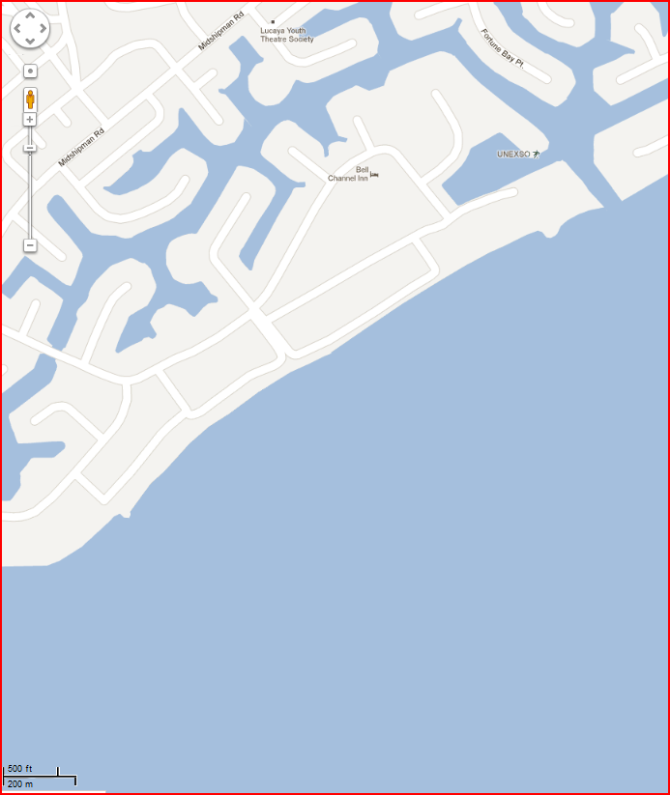
Satellite image of Taino beach area
