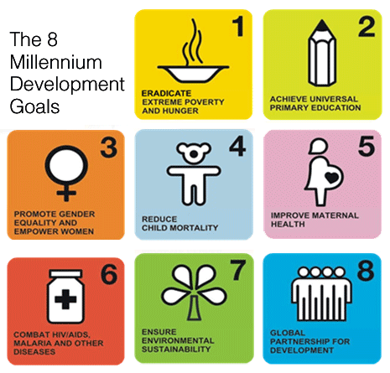
Make Poverty History: Your Campaign

Choose one of the
Millennium Development Goals
OR
Another Goal Proposed In Class

Complete the Following Steps in Your Campaign

- List your goals/targets for the campaign – what do you want to accomplish?
- Create a mission statement which reflects your goals.
- Create a logo (picture) and a catchy slogan (saying) for the project.
- Create a ‘pitch’ – a story about why people should listen to your campaign

- Create a 2 minute video which features:
- an explanation of your MDG; where in the world does it occur/who does it affect?
  - (hint: use your speed networking speeches! Use facts!)
- your campaign goals clearly explained
- your logo and slogan
- your pitch or storyline which will be the theme of the film

We will show the films in class on the last day before exams:
December 8th 2015
You will have three class periods to complete the filming
Rubric: Public Awareness Campaign

CATEGORY | 4 | 3 | 2 | 1
Brainstorming Solutions | Students identify more than 4 reasonable, insightful possible solutions/strategies to encourage change. | Students identify at least 4 reasonable, insightful possible solutions/strategies to encourage change. | Students identify at least 3 reasonable, insightful possible solutions/strategies to encourage change. | Students identify fewer than 3 reasonable, insightful possible solutions/strategies to encourage change.
Research/ Statistical Data | Students include 4 or more high-quality examples or pieces of data to support their campaign. | Students include at least 3 high-quality examples or pieces of data to support their campaign. | Students include at least 2 high-quality examples or pieces of data to support their campaign. | Students include fewer than 2 high-quality examples or pieces of data to support their campaign.
Campaign/ Product | All factors adequately represent the issue and are catchy for audience. Carefully crafted with obvious effort put into all. | Most factors adequately represent the issue and are catchy for audience. Carefully crafted with obvious effort put into most. | One factor is adequately represent the issue and are catchy for audience. Carefully crafted with obvious effort put into most. | The product is not accurate. Little effort put into some factors.
Classroom Effort | Student is on task throughout all classes. Obviously engaged in project and committed to final product. Teamwork and support with partner evident. | Student is on task throughout most classes. Engaged in project and committed to final product. Teamwork and support with partner present. | Student is occasionally on task throughout most classes. Sometimes engaged in project. Teamwork and support with partner may be lacking. | Student is rarely on task throughout most classes. Lack of engagement in project and lack of support or teamwork with partner.

