Peri-Glacial Processes (and Resulting Landforms)

Complete the following table from the lecture in class, pay attention to whether I have filled in the description of the process or the resulting landform in the table. You are only required to complete the empty box using your own words from the notes.

TASK 1:
Complete the table below in class (or for homework) using the notes from the powerpoint..

Process | Description: | Resulting Landforms
Freeze-Thaw Action: |  | In periglacial areas, screes develop at the foot of slopes due to frost shattering  On relatively flat areas, extensive spreads of angular boulders are left, known as blockfield or felsenmeer
Frost-Heave: | - Results from the direct formation of ice crystals in the soil as it starts to refreeze  - On freezing, fine-grained soils expand unevenly upwards to form domes.  - As stones cool down faster than the soil, small amounts of moisture in the soil beneath the stones freeze and turn to ice, expanding by 9% as they do so.  - By repeatedly freezing and thawing over time, these ice crystals and lenses heave stones upwards in the soil.  - This can cause pavement or soil to crack and bulge. | Forms Patterned ground:  Either stone polygons or stone stripes:
Ground Contraction: |  | Forms another type of patterned ground, without stones of the frost heave processes above, called ice wedge polygons.
Thermokarst: |  | Forms hollows: small depressions in the earth’s surface caused by seasonal or short term incidents melting ice and soil.  Lakes and drying lakes, fens and bogs, gullies and slumps
Groundwater Freezing: | - Freezing of water in upper layer of soil where permafrost is thin or discontinuous leads to the expansion of ice within the soil  This causes the overlying sediments to heave upwards into a dome-shaped landforms.  - On the site of small lakes, groundwater can be trapped by freezing from above and by the permafrost beneath as it moves in from the lakeside | Pingos:
Solifliction: |  | - Creates slumping of earth, sometimes referred to as solifliction lobes which are tepped features below vegetation, pushed forward and rolled under  - Where vegetation is sparse, stones heaved to the surface are pushed to the front of the advancing lobe and form a small stone bank at the front of the lobe  - Many parts of southern Britain experienced these conditions during the Quaternary ice age and these deposits, filled in valleys

TASK 2:
In the column below, name the landform shown and describe what has happened in the picture, identifying and describing the process in your own words, you can use the table above for reference. You should aim for 3-4 sentences in the description

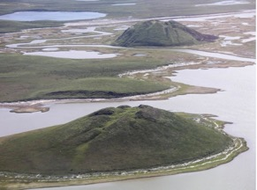 | 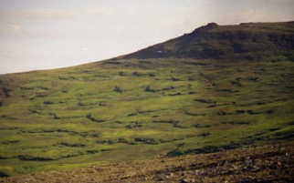
Landform:  Process Description: | Landform:  Process Description:
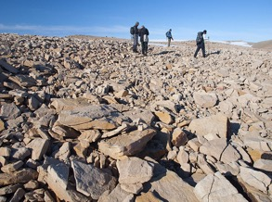 | 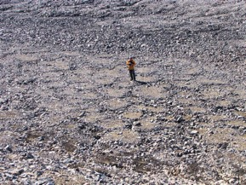
Landform:  Process Description: | Landform:  Process Description:
 | 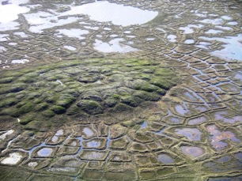
Landform:  Process Description: | Landform:  Process Description:

Task 3:
Produce a labelled sketch in your sketchbook to show characteristics of a pingo and suggest an explanation for its formation using annotations. Full colour should be used.

Annotations: maximum 10 word entries underneath a label explaining processes.

Task 4:
Answer the following questions, paying attention to the mark totals.

- Explain what permafrost is and where it is found. [4 marks]
- Explain a reason for the formation of patterned ground in periglacial environments. [4 marks]
- Explain the periglacial process of solifluction. [4 marks]
- Explain the appearance of thermokarst environments. [4 marks]

