Global Patterns of Cold & High Altitude Regions
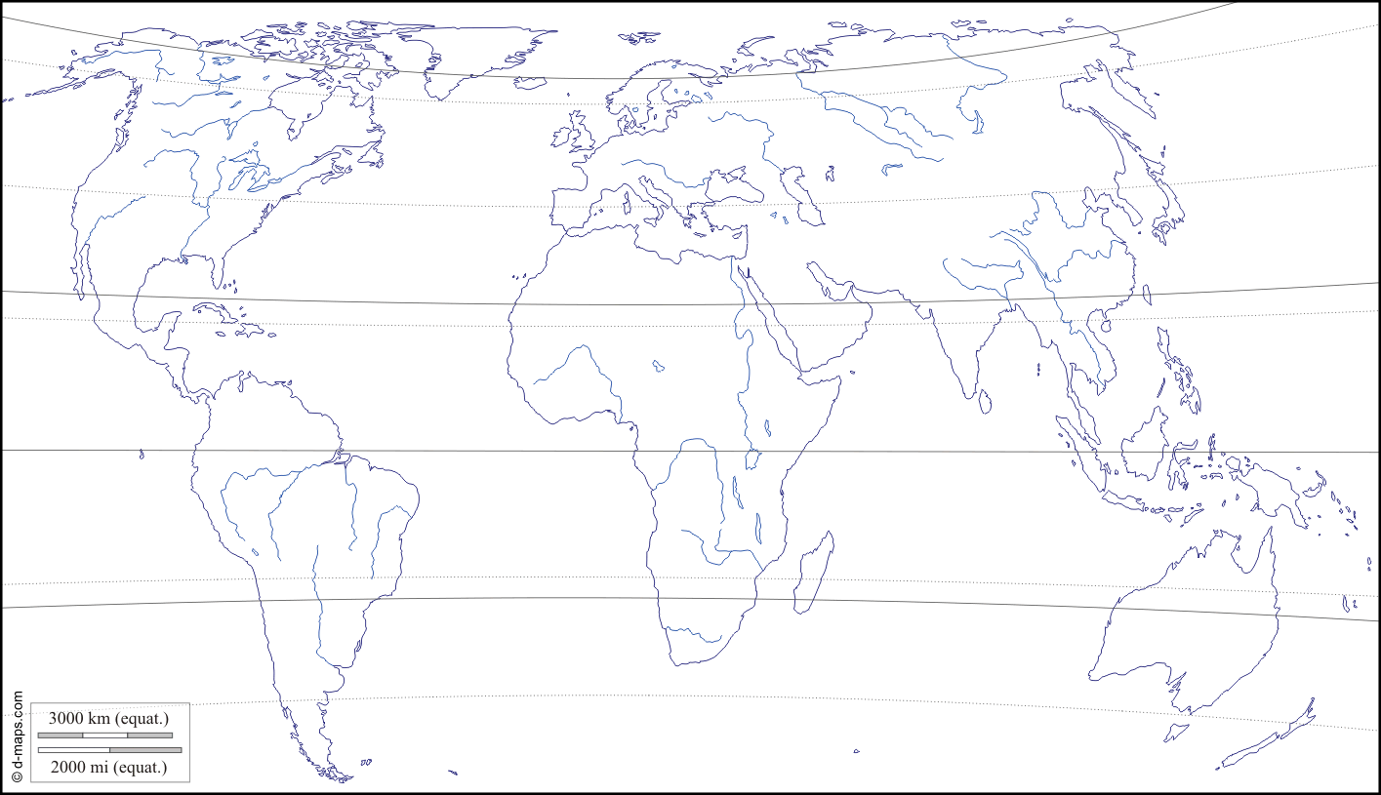

Task 1: On the outline map above, indicate the locations of the World’s cold and high altitude regions by completing the following and creating a legend.
- Begin by using the Koppen Climate Classification to colour the Arctic, Tundra, and Ice Cap regions of the world. (check)
- Then use the map of the Global Distribution of Glaciers to darken in the areas where glaciers exist. (check)
- Lastly, look at the map of the World’s Tallest Mountain Peaks. Label and record the elevation of the ten tallest mountains on earth. (check)

Task 2: Below, describe the pattern of global distribution of cold and high altitude regions. Where do we see the highest and lowest concentrations of cold environments and why might this pattern exist? Where do we see the last surviving glaciers and highest peaks? You should attempt to refer to lines of latitude, continental region and bodies of water in your answer.

……………...……………...……………...……………...……………...……………...……………...……………...……………...……………...……………...……………...……………...……………...……………...……………...………………

……………...……………...……………...……………...……………...……………...……………...……………...……………...……………...……………...……………...……………...……………...……………...……………...………………

……………...……………...……………...……………...……………...……………...……………...……………...……………...……………...……………...……………...……………...……………...……………...……………...………………

……………...……………...……………...……………...……………...……………...……………...……………...……………...……………...……………...……………...……………...……………...……………...……………...………………

