Advanced Population Pyramids – Different Elements of Population Structure
Task 1
In each box write down what the population pyramid tells you about the aspect of population structure shown in bold. Use specific data from the table to support your answer (ie: We can see that roughly 50% of population between 18-65).
Migration
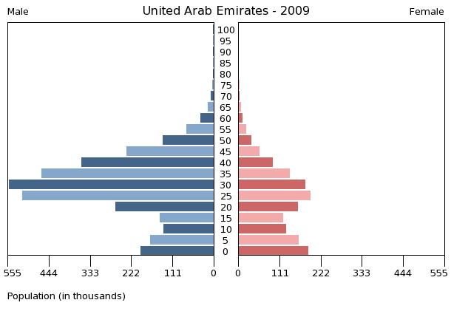

Ethnicity
Turks compared to German population in Germany
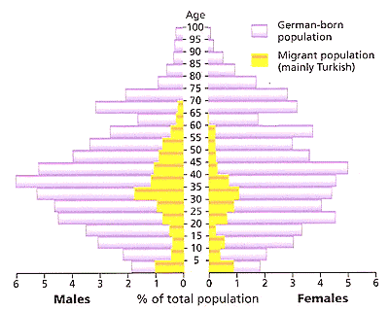

Impact of AIDS epidemic in Botswana

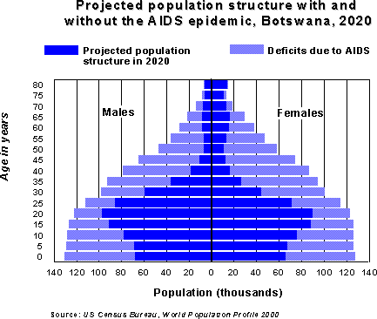

Ethnicity
Hispanic compared to white population in one area of USA

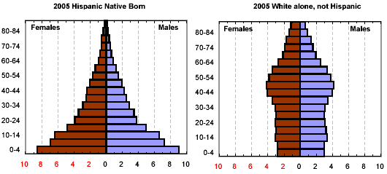

Migration

Aging Population

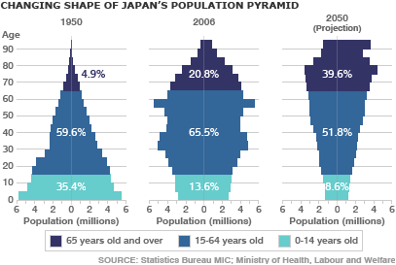

Task Two:
Read pgs 13-14, entitled “Japan’s Ageing Population” and record the problems associated with this phenomenon:

