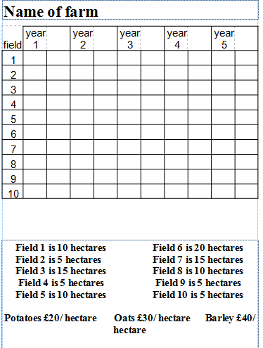

**Potatoes and Carrots – $20 / hectare Peas and Corn $25 / hectare**

**Oats and Oilseed Rape - $30 / hectare Barley - $40 per hectare**

**Tulips - $40 / hectare**