IB Geography
Tourism as Development Case Study – Vietnam
Find Map, Place Here
Introduction to Vietnam:
Location:

Brief History since 1900’s (Use the second half of notes from the ‘tourism as development strategy ppt’

Population Size:

GDP PPP:

Main Industries:

Main Crops Produced:

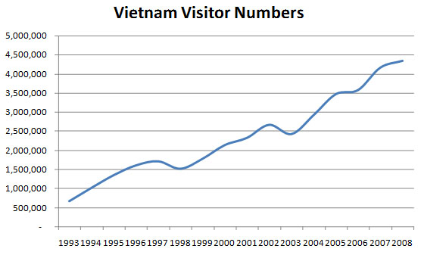
Growth of Tourism in Vietnam
Describe the trends shown on the graph (general trend, high points, low points, use some data… 3-4 sentences):

Reasons for growth – Match the two sides of the coin using copy and paste for definition match!

Heads | Tails
Improved transportation | Visas are still required, but these are now a lot easier to obtain.
Deregulation | The war has been finished over 30 years and now tourists are saying much better things about Vietnam.
Relaxed immigration | at home and abroad.
Better image | Vietnam still has a communist system, but the ruling party has allowed greater private ownership.
Better advertising | hotels and restaurants
Investment in | especially air travel, which is the main way most tourists arrive
Exchange rate | of neighbouring countries like Thailand and Malaysia.
Saturation | once you are in Vietnam it is still a relatively cheap place to visit
Foreign Direct Investment
Infrastructure
Economic Leakage
Key words: Match with definitions
… money spent in a country by a foreign company or country. Countries try and attract FDI by setting up enterprise zones, low tax rates, relaxed planning, etc.
… Money that is generated in a country, but then leaves the country. This normally happens when there are a large number of TNCs, removing money and sending it back to their home country.
… A country's or business's basic underlying structure and framework e.g. the buildings, transport and electricity and water supply.
Physical & Human Attractions

HUMAN ATTRACTIONS | PHYSICAL ATTRACTIONS
- Hoi An: a beautiful town situated on the mouth of the Thu Bon River. It has Dutch, French, Japanese, Vietnamese and Chinese influences and has been designated a UNESCO world heritage site.  - Hue Citadel: Built in the early 19th Century the citadel was damaged during the war, but is being rebuilt and can be visited by tourists. It too has also been designated a UNESCO world heritage site.  - My Son: The old Cham capital is located in Central Vietnam. It was damaged during the Vietnam war but has been designate a UNESCO world heritage site and is been rebuilt and protected.  - Cu Chi Tunnels: Used during the Vietnam war by the Vietcong, these tunnels along with others up and down the country can be visited by tourists.  - Con Dao Prison: Used by the French and the Vietnamese, this once notorious prison has now been turned into a museum. It is situated on the beautiful and remote Con Dao Islands.  - Ho Chi Minh Mausoleum: Like Lenin and Mao, Ho Chi Minh was embalmed after his death. You can now visit his embalmed body in Hanoi.  - Temples: A number of religions are practiced in Vietnam including Catholicism, Buddhism and the unique Caodaism. Each religion has its unique temples which can be visited. e.g. Temple of Literature and Cao Dai Temple.  - Food: Vietnam has fantastic food e.g. Pho and Spring Rolls. Tourist visit to try the food and learn how to cook it. | - Halong Bay: Thousands of limestone karsts situated off the coast of North Vietnam in the South China Sea. Halong Bay has been designated a UNESCO world heritage site.  - Phu Quoc Island: A beautiful island off the south coast, this has become one of Vietnam's premier tourist destinations.  - Mekong Delta: Formed at the mouth of mighty  - Mekong River, this depositional landform has become a popular tourist destination with people wanting view the deltas traditional way of life.  - Central Highlands: The heart of Vietnam's coffee industry, the central highlands also has stunning scenery and beautiful waterfalls.  - Fransipan. This is Vietnam's tallest mountain and found in the north of the country. The surrounding area has both beautiful scenery and unique tribes, both of which tourists enjoy to visit.  - Lang Co Beach: A beautiful spit in Central Vietnam that has a peaceful lagoon behind it.  - Mui Ne: Probably Vietnam's most popular beach destination, the area also has impressive sand dunes and is popular with kite surfers.  - Whale Island: Near central Vietnam, Whale Island has become an exclusive beach retreat which is great for diving.  - Wildlife: Vietnam has incredibly diverse animals, ranging from primates, to large mammals, to reptiles and amphibians e.g. tigers, elephants and dugongs.

Images
Using the Physical and Human Attractions listed above, find three images that show primary and three that show secondary tourist resources of in Vietnam. Provide a border, subtitle and label for each of the pictures.
Primary

Secondary

