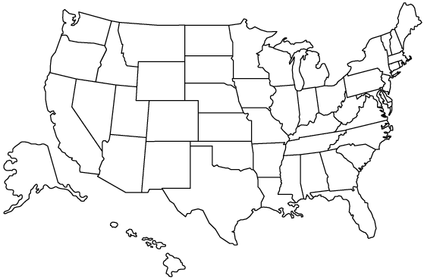
Relief Geography
Shade the different elevations
and label the following:
Appalachian Mts.
Rocky Mtns.
Sierra Nevada
Central Plains
Great Plains

Climate Regions:
Label and shade the following:
Cold and Dry
Cold and High
Mild and Wet
Very Wet
Dry

Rivers and Oceans
Draw in and label the following:
Mississippi River
Missouri River
Rio Grande
Pacific Ocean
Atlantic Ocean

Complete the map below by labelling all 50 states in the United States of America. Add compass!
Complete the map below by colouring one other demographic or climatic factor from pages 94-99 of the atlas.

