Preventing Desertification:

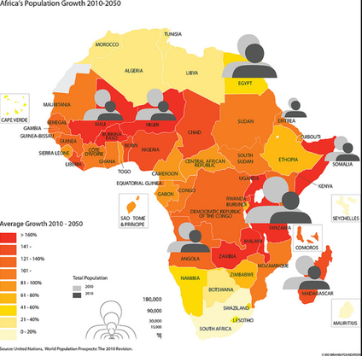
The maps below show Africa’s Predicted Population Growth (left) and Areas At Risk of Desertification (right);

- Describe the pattern of population growth below.

- Suggest how the pattern you’ve described above matches the areas of desertification most at risk in Africa. What is the issue here? Use country names and regions in your response.

- How does human population growth pose a threat for those areas already at risk of desertification? Using the britishgeographer website under the section ‘The Challenges of Desertification,’ briefly describe the unsustainable human activities that contribute to desertification in the Sahel.

Describe:
deforestation

unsustainable grazing

sedentary farming

overcultivation

monoculture

- What is carrying capacity?

- On the stpgeography website look at section 4.Desertification & Climate Change. Go to 4d) Strategies for Management, and watch both videos there. Summarize below the key strategies these communities are using to combat desertification.

“Turning the Tide on Desertification” – Acacia Trees in Senegal (Part of the Great Green Wall in Africa)

Re-greening Ethiopia – A Different Type or Grazing

