TITLE:
TASK ONE:
Identify the stage of the DTM for each of the countries listed on the website:
Germany:
Sweden:
Chile:
Mauritius:
China:

TASK TWO:
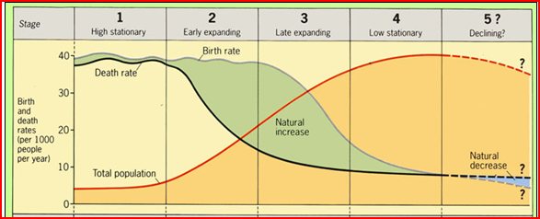
Describe the birthrate, death rate and total population
Explain reasons for this description | Pg 3 and 7 | Page 7 | Pg 3, 4 and 7 | Pg 9 | Pg 6
http://www.youtube.com/watch?v=0dK3mL35nkk

TASK TWO:
- What is the key change in a country moving to stage 2.
- What is the cause of this key change?
- What is the key change in a country moving to stage 5.
- What is the cause of this key change?
- What issues can you see arising for a country in stage 5?
- Is the DTM a good model of population change?

