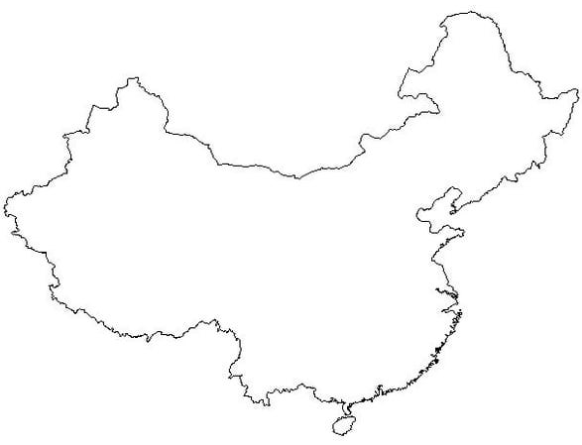
Relief Geography
Locate and label the following outlines:
Shade the different ‘steps’
Taklimakan Desert
Plateau of Tibet
Himalayas
Gobi Desert
Huabei Plain
Dongbei Plain
Pearl River Delta

China’s Climate Regions:
Locate and Draw in Colours for the following:
Very Dry
Cold, High and Dry
Mild and Wet
Cold, Very Wet
Dry

Rivers and Deserts
Locate and Draw the following:
Yellow River
River Yangtze
River Xi
HSouth China Sea
East China Sea

