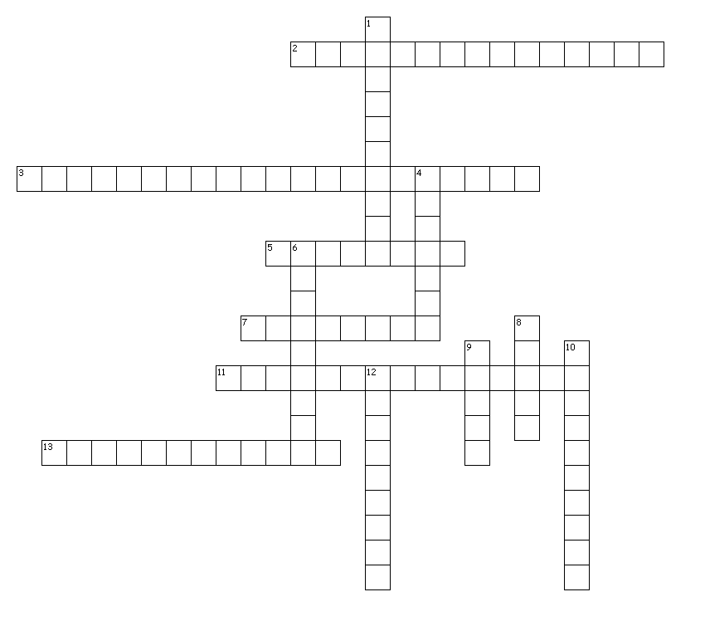

Across
2. The force of the waves hitting the coast force pockets of air into cracks and crevices, widening joints until portions fall off the cliff and into the sea
3. The growth of tree roots in between rocks causes the rock to crack and decay
5. The part of tidal movement which moves back down and away from the beach
7. This happens when waves pick up stones and throw them at cliffs, wearing the cliff away
11. The type of high energy wave which erodes the beach or cliff
13. The removal of cliff material, which falls under the influence of gravity in the form of landslides

Down
1. The cracking of rocks due to continuous freezing and warming; liquid expanding and shrinking
4. The wearing away of rocks by wind or water
6. Material carried by the waves becomes rounded and smaller over time as it collides with other material in the water. Does not act on the coast itself but creates the material for abrasion
8. The forward movement of waves
9. The distance over which the wave travels before it lands on the coastline
10. The breakdown of rocks caused by natural processes (besides wind and rain)
12. When salts and other acids in seawater slowly dissolve a cliff

WORD BANK:
CORROSION
ABRASION
ATTRITION
EROSION
WEATHERING
HYDRAULIC ACTION
FREEZE THAW
BACKWASH
BIOLOGICAL WEATHERING
DESTRUCTIVE WAVE
FETCH
SWASH
MASS MOVEMENT
(note: there are no spaces in the crossword puzzle)

