ARID LANDSCAPE FEATURES
Anatomy of a Flash Flood Article:
Questions:
How do flash floods happen?
Where are the places the author in this article writes about? (place name, look up country)
Why does this author believe that understanding flash floods is important?
Basic Concepts:
I. Most deserts exhibit highly angular landscapes.

II. Softer, more rounded landscapes appear where deposition is predominant.

III. Desert rainfall is infrequent, intense, and unreliable.

IV. DESERT LANDFORMS are shaped by WEATHERING, EROSION and DEPOSITION

Destructive processes break down landforms through weathering and erosion.
Weathering is:
FROM TEXT:
- SALT Crystallization is:
- DISINTEGRATION (and exfoliation) is:
- Regolith is:
Erosion is:
WATER (Fluvial):
FROM TEXT:
- Exotic Rivers are:
- Endorheic rivers are:
- Ephemeral rivers are:
WIND (Aeolian):
FROM TEXT:
- Deflation is:
- Abrasion is:
Constructive processes build up landforms through tectonic and depositional processes.
Deposition is:
WATER (Fluvial):
WIND:

Use text book pg. 123-127 and thebritishgeographer information from the website to add detail to your table
For EACH Landform Below, include a Picture | Description  (in your own words WHAT) | Type of weathering (and briefly HOW it is formed) | Where in the world?  (ONE example) | Hard/soft rock
Butte
Mesa
Plateau
Canyon
Wadis
Pediments (piedmonts)
Barchans
(crescent dunes)
Oasis
Alluvial Fan
Salt Pan
Rock Pedestals
(use web for info)
Yardang / Zeugan

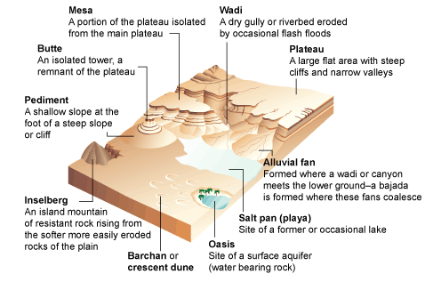

DESERT LANDFORMS:

I. Most deserts exhibit highly angular landscapes.

II. Softer, more rounded landscapes appear where deposition (WIND deposits material) is predominant.

III. Desert rainfall is infrequent, intense, and unreliable.

