Volcanic Eruptions:

- Describe the following parts of the volcano in one sentence each: (LINK: Owlcation)

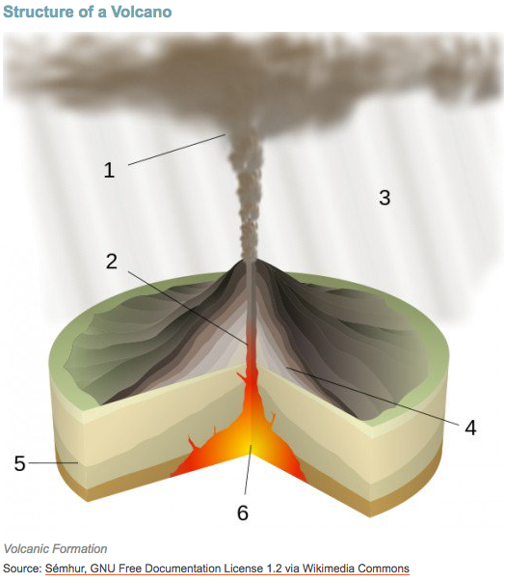

- Ash Plume

- Central Vent

- Volcanic Ash Rain

- Layers of Basaltic Lava

- Earth’s Crust

- Magma Chamber

- Distinguish Between the following eruptions: (Text p167/168 or LINK: Geology.com)

(Effusive Eruptions) Lava Eruptions:
Hawaiin:
Icelandic:

(Explosive Eruptions) Pyroclastic Eruptions:
Strombolian:
Vulcanian:
Plinian:

- Distinguish between types of volcanic hazards:

What are primary hazards?
Describe in one sentence: lava flows, ash fallout (tephra), pyroclastic flows, gas emissions

What are primary hazards?
Describe in one sentence each secondary hazards: landslides, lahars, volcanic gases

- Find 2 – 3 diagrams from internet that show primary and secondary hazards above and paste below.

- Label the following types of eruption below. Can you tell which is which?

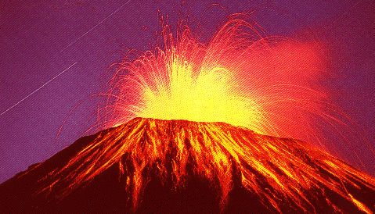 | 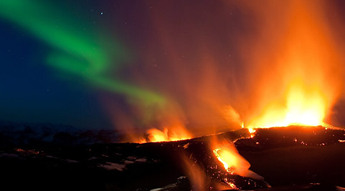
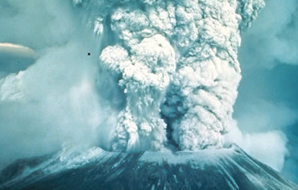 | 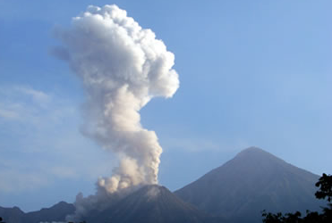
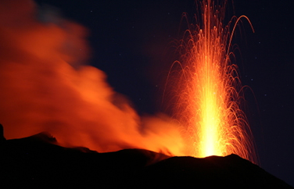 | 