Characteristics of Volcanoes

- Intro to Volcanoes (Video):

Approximately ____ volcanoes are currently considered active (meaning it has erupted since the last ice age or in the last 10 000 years). Of all the currently active volcanoes, approximately _____ lie within the Ring of Fire (a band circling the Pacific Ocean ). Volcanoes form where tectonic plates _____ . Magma is _______ that erupts through rifts or collisions in the earth’s plates.

- ____________ in Italy has been erupting for more than 3,500 years. The first eruption occurred in 1,500 BC.
- Kilaueavolcano in Hawaii is a youngest shield volcano which has been erupting continuously since 1983. This makes Hawaii the only state in the US that is ______________.
- The ______________ formed over a hotspot in the middle of the Pacific plate.

- Origin of Volcanoes:
There are three main places where volcanoes originate:
- Hot Spots
- Divergent plate boundaries (such as rifts and mid-ocean ridges)
- Convergent plate boundaries (subduction zones)
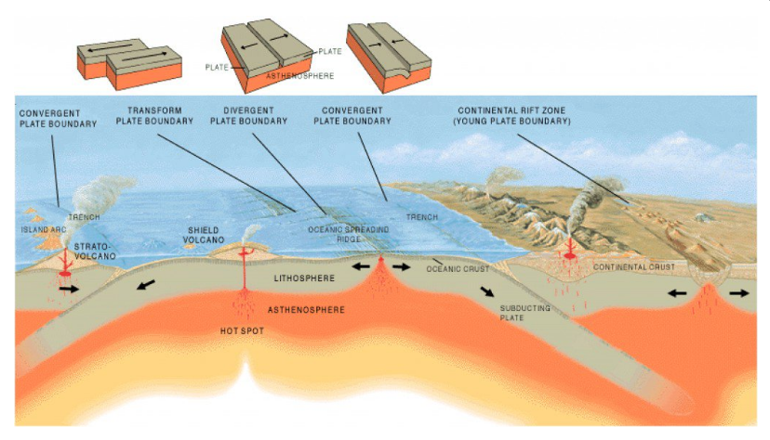

Define ‘hotspot’:

Describe how a volcano forms at a convergent plate boundary:

Describe how a volcano forms at a divergent plate boundary:

- Types of Volcanoes:
There are three types of volcanoes we will learn here. Use the internet or your textbook to complete the WS.
Suggested websites: Owlcation, USGS, or ZME Science OR: textbook (p166)
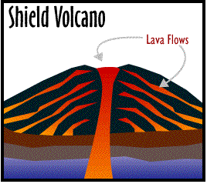
How do they form?

Key Characteristics (structure, lava, activity):

Specific Examples (two):

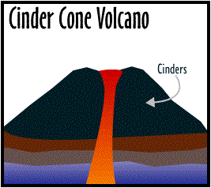
How do they form?

Key Characteristics:

Specific Examples (two):

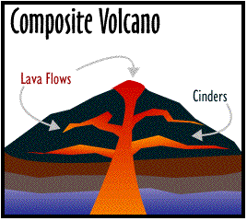
How do they form?

Key Characteristics:

Specific Examples (two):

Three Different Volcano Types:

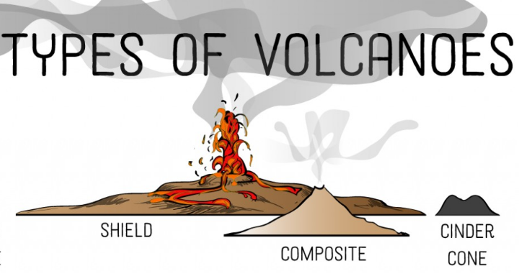

Table of Different Volcano Types:

