Aim:
Notes:

Task 1
Evidence of a disease of affluence in Mexico from video. What is the connection?

Not just a disease of affluence – how is poverty involved?

Why is this a long term problem for Mexico?

Task 2
http://www.theguardian.com/world/2014/jan/16/mexico-soda-tax-sugar-obesity-health

What health problems are an issue in Mexico?

What is the tax proposed?

How will this tax prevent illness?

What NGO’s are involved?

How does this issue link with water scarcity?

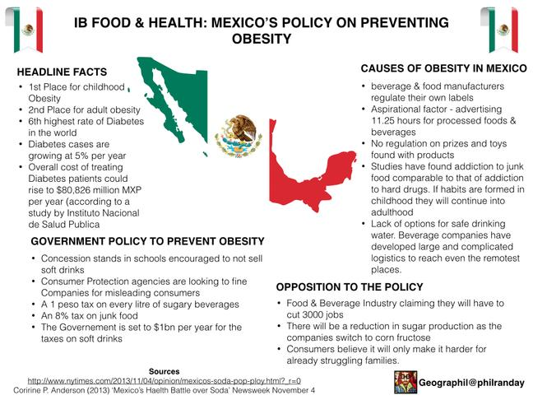

Task 3
Referring to one or more diseases, discuss the factors that determine the relative importance of policies of disease prevention rather than disease treatment. (10)

