Aim:
Epidemological transition:

Key vocab:
the number of cases per 10,000 population
the number of confirmed cases annually
Infectious disease – may be contagious and transmitted by close human contact or vectors eg. malaria, HIV-AIDS
Transmitter of disease such as insects
Degenerative diseases that may be associated with old age or lifestyle associated in a HIC such as high energy diet or low level of physical activity or smoking

Put these statements into order to explain the epidemiological transition:

http://www.healthmetricsandevaluation.org/gbd/visualizations/gbd-2010-patterns-broad-cause-group
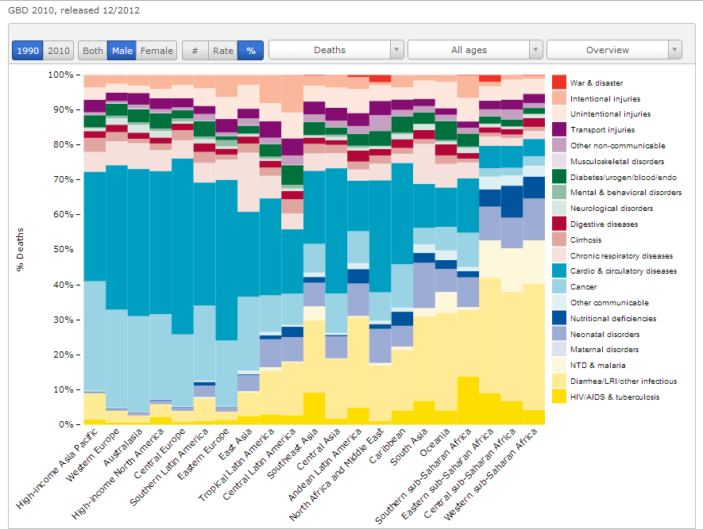

Analyse this graph to show evidence for the epidemiological transition

Explain the global distribution of cholera (5)
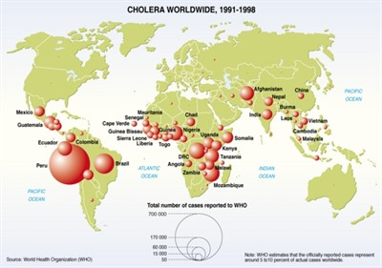

Explain the global distribution of diabetes (6)
