Aim:

Task 1
Classify these into push and pull factors
Planning laws
Ethnic cleansing
Natural disasters
Ill health
Harsh climate
Civil unrest
Poverty
Good welfare and other services
Family ties
Freedom of speech
Attractive views
Political asylum
High living standards
Propaganda
Divorce
Unemployment
Shortage of housing
Inaccessibility
Children leaving home
Up and coming neighborhood
Good wages
Declining neighborhood
Hazard free environment
Low population density
Cheap land
Too many people
Safe and secure
Promotion at work
Marriage

Push factor | Pull factor

Task 2
Lees Migration model Notes:
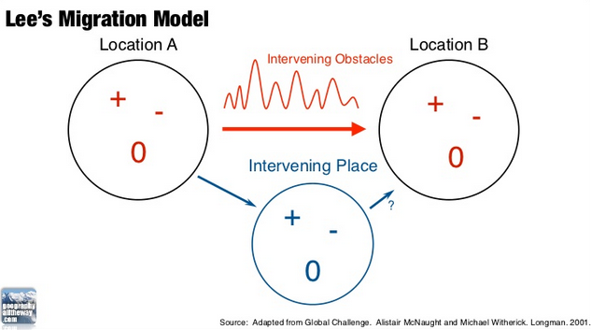

Give some examples of intervening obstacles:

Task 3
Can we apply Lee’s model to Syrian migration to Europe?
Read either article below. Constrict Lee’s Migration Model in your notebook (as above) based on the stories described. Identify Location A, Intervening Place, Intervening Obstacles, Location B specific to the case study of either Syria to Gothenburg or Syria to the UK.
The Calais Jungle (Syria or Afghanistan to UK)
The Harrowing Journey (Syria to Sweden)

Task 4
What are Ravensteins laws of migration. Use video from website or PPT to copy them down.
Highlight which you think are the most important three and justify your choice

