Notes:

Community size | Facilities found | Activities offered
Village  500-1500 people | Village hall or community hall  Community open space in centre of village
Town  2500-6000 people | As above plus  Tennis courts  Sports halls and swimming pool – may be attached to a large school
City  6000 + people | National sports centre eg. Dunstall racecourse in Wolverhampton  Larger facilities such as Olympic size pool

Task 1 Vocab – Place the words below with the correct definition

Placing things in an order of importance.
The minimum population required for a service to be offered.
The area that people travel from to use a service.
Urban means a settlement of over 10,000 people, intra means within. Therefore, this means within an urban area.
The boundary between the urban area and the rural area.
The main centre of tourist activities and facilities within an urban area.
The purposes or jobs of a settlement. As a settlement grows the size and importance of the tourism function will normally increase.
An outlying part of a city or town, within commuting distance to the CBD
The area and population from which a facility or region attracts visitors or customers

TBD or RBD (Tourist or Recreational Business District)
Threshold population
Suburbs
Intra-urban
Catchment area
Hierarchy
Functions
Sphere of influence
Rural-urban fringe

Task 2 - Fill in the Natural, Economic, Social for the patterns of distribution of leisure facilities. Add one of your own examples from the city in your choice in a different colour for each example.
Natural
Economic
Social

Space: Some recreational activities take up a lot of space e.g. golf. It would not be possible to find enough space in the centre of the town to build a golf course.
Historical Location: Historic buildings are normally found in the centre of urban areas. The reason main historic buildings e.g. castles and cathedrals were built at the same time the urban area was settled, so the urban area has grown around them.
Land value: Some recreational facilities will not be able to afford to locate on higher value land. For example a local cricket pitch would not locate on expensive land because it does not generate enough income. However, a five star hotel might locate on high value land because it generates lots of income.
Land Use of Surrounding Area: Some recreational facilities will be attracted to certain locations. For example a hotel would normally be located in the TBD or on a good transport link, because this is what tourists demand. They would not locate in in the middle of a residential area, because demand would be less. Alternatively a library or sports centre is more likely to be located in a residential area, because this is where the demand will be.
Accessibility: Some recreational facilities need a higher threshold population to be offered e.g. shopping centres, therefore they need to be in a location with a large population and are easily accessible. Facilities like new sports stadiums are also built near main roads or good public transport links.
Socio-economics Status: Some recreational activities e.g. golf are expensive to participate in. Because of this some facilities will locate in areas of higher socio-economic status. Alternatively football is traditional a more working class sport so football clubs (recreational not professional) maybe located in more working class areas.
Physical Characteristics: Some recreational activities are dependent on the physical environment e.g. potholing, fishing and skiing. Because of this you are not going to find some recreational facilities inside urban areas, but more in the rural-urban fringe or rural areas. Areas that have outstanding natural beauty or great weather may also have above expected facilities e.g. the island of Menorca in the Mediterranean or Monteverde in Costa Rica.
Sports Events or Exhibitions: Some cites areas may have above expected tourist or recreation facilities because they have recently hosted a major sports event, conference or exhibition. Qatar in the Middle East has a population of only 1 million but will host the football World Cup in 2022. After the World Cup many settlements in Qatar will have more tourist and recreation facilities than you would expect for a settlements of their size.
Advertising and Recognition: Some locations are very good at promoting themselves and attracting new customers and users and therefore have above expected facilities for their size e.g. the Bahamas, Dubai or Phuket in Thailand.

Task 3 – Nasty IB diagram
Can you explain what this diagram is trying to show?
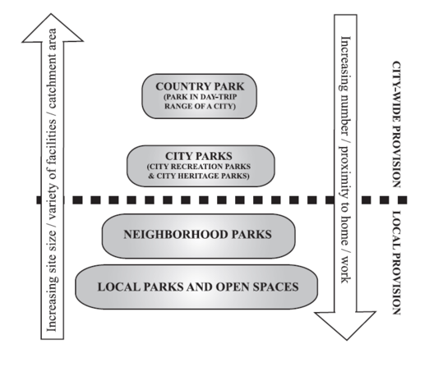

Task 4: In your notes PROVIDE a detailed description of munich, using the terms from this lesson. EXPLAIN the location of at least two specific leisure facilities in each PART of the four urban areas (CBD, inner city, suburb, urbal-rural fringe).
Some examples you could use:
- Swimming pools/community centers, golf courses, Libraries – central and branches, Theatres, Museums, Public parks, Stadiums, Other leisure facilities (Zoo, Theriesenweisse,…?)

