Aim:
The basics
Migration is:

Main trends in migration:

THREE KEY OBSERVATIONS FROM THE MAP BELOW:
1.
2.
3.
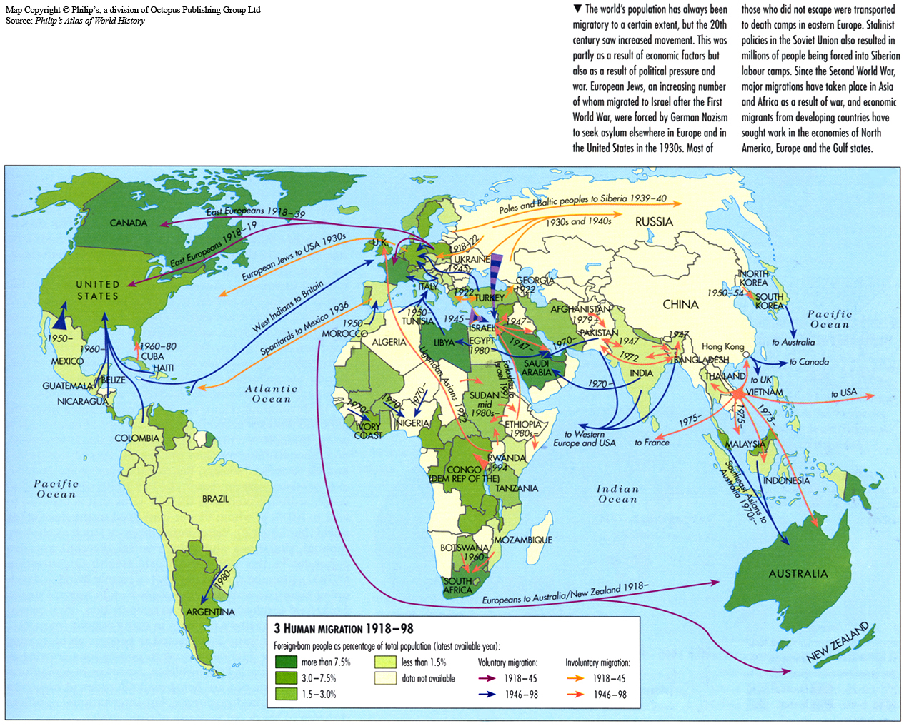

Vocabulary – find a definition for each of these words pg 16-22
Remittance
Source country
Host country
Emigrant
Immigrant
Refugee
Asylum seekers
Illegal immigrants
Economic migrant
Internally displaced person (IDP)
Task 1: Create a short paragraph summary of Germany’s migration Using the LINK here
INCLUDE:
- Which countries it receives migrants from
- Where most migrants come from and ranking in 'migrant corridors'
- Percentage of emigrants and top destinations

Task 2
Outline the major positives and negatives of Turkish economic migration to Germany.
Positives | Negatives

Think about both the source and host country. Be specific in your answers.
Use these websites to help you.
https://www.washingtonpost.com/news/worldviews/wp/2016/07/18/home-to-3-million-turkish-immigrants-germany-fears-rising-tensions/
https://www.thelocal.de/20150615/migrant-workers-send-14-billion-to-families-back-home-spain
https://www.thelocal.de/20111026/38441
http://www.dw.com/en/germans-warm-up-to-immigration-but-miss-the-point-say-experts/a-15486818

