The Spatial Distribution of Landslides:

Use the chart below to complete the following questions (from the IB Geo Course Companion Oxford):

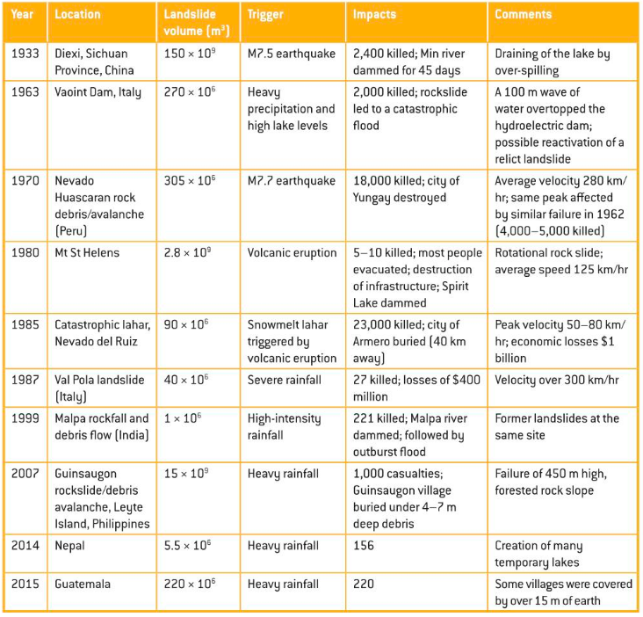

- Identify in order the most common cause of landslides in the 20th and 21st centuries.
- Contrast the impacts of landslides over time. Use specific data from the chart in your answers.
- Describe how landslides are measured.
- Identify the locations of the listed landslides.

Hazards and RISK: Landslides

Use the chart below to complete the following questions (from the IB Geo Course Companion Oxford):

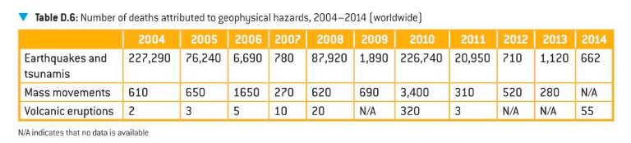

- Work out the total number of global deaths for each hazards over the ten year period shown.

- Work out the total number of deaths from geophysical events in each of the years. Comment on the trend in deaths as a result of geophysical events.

- Work out the average number of deaths for each hazard per year.

- Identify the natural hazard that caused the greatest number of deaths.

- Suggest why (using geographic factors) this hazard can involve the least amount of risk to humans.

- State the natural hazard that caused the least loss of life in total.

- Suggest why (using geographic factors) this hazard can involve the least amount of risk to humans.

- Compare the number of deaths by main cause of death in 2004 and 2010.

- Complete a little research to determine the reasons behind your answers for question 7.

Ensure you understand the following terms relating to risk and hazards:

Recurrence Interval:

Mortality:

Vulnerability:

Risk:

Demographic Factors:

