Global Patterns of Hot/Arid regions
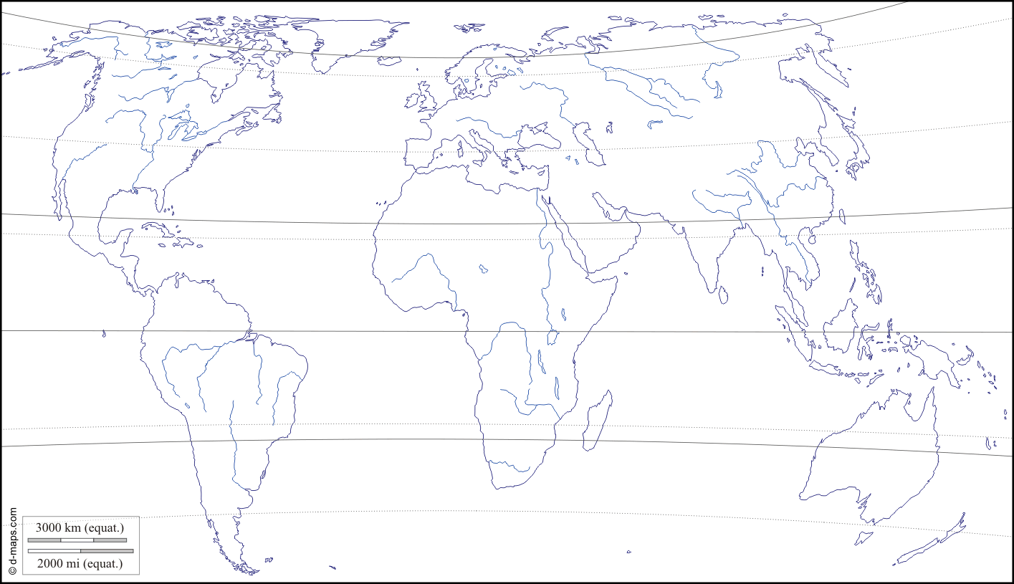

Task 1: On the outline map above, indicate the locations of the World’s hot/arid regions. You should refer to page 169 of the course guide for the regions in question. For each hot/arid region you should: name it, state the
country(ies) in which it is found, state the areal extent and whether it is a cold or hot desert type.
Task 2: Below, describe the pattern of global distribution of hot/arid regions. You should refer to lines of latitude, continental region and bodies of water - indicate these on the map, if you refer to them in your description.

……………...……………...……………...……………...……………...……………...……………...……………...……………...……………...……………...……………...……………...……………...……………...……………...………………

……………...……………...……………...……………...……………...……………...……………...……………...……………...……………...……………...……………...……………...……………...……………...……………...………………

……………...……………...……………...……………...……………...……………...……………...……………...……………...……………...……………...……………...……………...……………...……………...……………...………………

……………...……………...……………...……………...……………...……………...……………...……………...……………...……………...……………...……………...……………...……………...……………...……………...………………

……………...……………...……………...……………...……………...……………...……………...……………...……………...……………...……………...……………...……………...……………...……………...……………...………………

……………...……………...……………...……………...……………...……………...……………...……………...……………...……………...……………...……………...……………...……………...……………...……………...……………...

……………...……………...……………...……………...……………...……………...……………...……………...……………...……………...……………...……………...……………...……………...……………...……………...………………

